Edmond Kangamungazi
CONSULTANT
ECONOMIC CONTRIBUTION OF ZAMBIA’S CULTURAL AND CREATIVE INDUSTRIES (CCIS)

Table of Contents
Acknowledgements 3
Acronyms and Abbreviations 3
DEFINATIONS 4
Executive Summary 5
CHAPTER 1: INTRODUCTION 10
1.1 Background and Context 10
1.2 Problem Statement 10
1.3 Rationale for the Study 11
1.4 Objectives of the Study 11
1.5 Scope and Structure of the Report 11
CHAPTER 2: LITERATURE REVIEW AND CONCEPTUAL FRAMEWORK 11
2.1 Introduction to the Literature Review 11
2.2 Positioning the Creative Economy in Development Thought 12
2.3 Measurement Frameworks and Their Limitations 12
2.4 Global Perspectives on the Creative Economy 12
2.5 African and Regional Evidence 13
2.6 Zambian Literature and Evidence Gaps 13
2.7 Conceptual Framework 14
CHAPTER 3: METHODOLOGY 14
3.1 Methodological Rationale and Research Design 14
Research Design 15
3.2 Data Sources 15
Secondary Data 15
Primary Data 15
3.3 Sampling Strategy 16
3.4 Economic Model: Enterprise and Economy-Wide Analysis 16
Econometric Model 16
Analytical Framework and Techniques 17
3.6 Ethical Considerations and Limitations 17
CHAPTER 4: Overview of Zambia’s Cultural and Creative Industries (CCIs) 19
CHAPTER 5. POLICY, LEGISLATIVE, INSTITUTIONAL, AND FINANCING ENVIRONMENT 21
5.1 Policy and Legal Framework Analysis 21
5.2 Institutional Environment 22
5.3 Financing Environment 23
5.4 Strategic Implications 23
CHAPTER 6: Contribution of the Cultural and Creative Industries to Domestic Revenue Mobilization 24
6.1 Introduction: Arts, Culture, and Domestic Revenue Mobilization 24
6.2 Contribution of the Creative and Art Sector to the Tax System of Zambia 24
6.3 Overview of Zambia Tax Performance between 2021 and 2025 25
6.4 The Creative and Arts Sector Performance on Tax 2021 to 2025 25
6.5 Creative and Art Sector Contribution disaggregated by Tax Type 25
6.6 Progression of the Creative and Art Sector Registration by Tax Types and Tax Revenue Collections 26
6.7 The Creative and Arts Sector Contribution by Sub Sector 2021 to 2025 27
6.8 Breaking the Barriers and Improving the Industry Contribution 28
6.9 Non-Tax Performance of the Arts and culture 30
6.10 Challenges of Impacting the Revenue Contribution on Non-Tax Revenue by the CIC Sector 30
6.11 Key Fiscal Findings for Policymakers and implications 31
CHAPTER 7: SUBSECTOR ANALYSIS OF ZAMBIA’S CULTURAL AND CREATIVE INDUSTRIES 33
7.1 Analytical Framing and Data Sources 33
7.2 Comparative Subsector 33
7.2 Music Industry 33
7.3 Film and Audiovisual Industry 34
7.4 Fashion and Crafts 35
7.5 Publishing and Visual Arts 35
7.6 Heritage and Cultural Tourism 35
7.7 Digital Media and Content Creation 36
7.8 Comparative Subsector Insights 36
Chapter 8.0 Financial Contribution and Forward Projections 36
chapter 9.0 Modelling Results and Analytical Interpretation 38
9.1 Public Investment and Sectoral Output Dynamics 39
9.2 Multiplier Effects and Economy-Wide Spillovers 39
9.3 Fiscal Returns and Tax Revenue Elasticity 40
9.4 Employment Effects and Youth Labour Market Outcomes 41
9.5 Optimal Allocation Ranges and Investment Efficiency 41
9.6 Key Findings and Discussion 42
Chapter 10 The CREATE Framework for Zambia’s Creative Economy Transformation 46
10.1 C – Classify and Recognise CCIs as an Economic Sector 46
10.2 R – Resource and Finance the Creative Economy 47
10.3 E – Enable Institutions and Coordination 47
10.4 A – Activate Markets and Formalisation 47
10.5 T – Track Data and Evidence Systems 48
10.6 E – Empower Skills and Enterprises 48
10.7 Integrated Impact of the CREATE Framework 48
chapter 11 Policy Recommendations and Strategic Options for Zambia’s Cultural and Creative Industries 49
11.1 IMMEDIATE PRIORITIES 49
11.2 Medium-Term Priorities (2–5 Years) 53
11.3 Long-Term / Structural Priorities (5–10 Years) 55
12.Conclusion 56
References 58

Acknowledgements
The successful completion of this study would not have been possible without the valuable support, guidance, and contributions of several individuals and institutions.
We would like to extend our sincere gratitude to the People’s Action for Accountability and Good Governance in Zambia (PAAGZ) team for their dedicated technical support, coordination, and constructive inputs that greatly strengthened the quality of this work. We are indebted to Mr. Khazike Sakala, Executive Director of PAAGZ for his strategic leadership, encouragement, and overall support throughout the study and seeing it to fruition.
Special appreciation is also extended to the National Arts Council of Zambia for their continuous support, insightful guidance, and facilitation during the research process. Their commitment to the development of the arts and creative sector provided a strong institutional foundation for this study. Gratitude is also extended to the Ministry of Youth, Sport and Arts, particularly the Department of Arts for their policy guidance, engagement, and support in shaping the direction of this research and ensuring its alignment with national priorities for the Cultural and Creative Industries.
We further wish to acknowledge the Ministry of Finance and National Planning for their cooperation and for providing critical insights and data that informed the fiscal and economic analysis of this report. We would like to take time to thank the creatives, artists and cultural practitioners that made input through their unwavering and modest insights into the individual and collective economic activities they undertake to give shape and reality to this report.
We would also like to acknowledge and commend the work of the consultant, Edmond Kangamungazi, whose expertise, analytical rigor, and dedication above and beyond his task commitment were instrumental in the successful development and refinement of this report.
Finally, we appreciate all stakeholders, practitioners, and respondents who contributed their time, knowledge, and experiences to this study. Their perspectives were invaluable in shaping a comprehensive and evidence-based understanding of Zambia’s creative economy.
The views and interpretations expressed in this report are those of the consultant and do not necessarily reflect the official positions of SELAM, PAAGZ, or any of the institutions acknowledged.

Acronyms and Abbreviations
AU : African Union
CAGs : Cluster Advisory Groups
CCIs : Cultural and creative industries
CCS : Cultural and creative sector
CfCA : Connect for Culture Africa
CSO : Civil Society Organization
EU : European Union
EU MS : European Union Member States
GDP : Gross Domestic Product
MGE : Mzansi Golden Economy
MoYSA : Ministry of Youth, Sport and Arts
MTEF : Medium-Term Expenditure Framework
NAC : The National Arts Council
NFVF : National Film and Video Foundation
PAAGZ : People’s Action for Accountability and Good Governance in Zambia
PPPs : Public-private partnerships
UNCTAD : United Nations Conference on Trade and Development
WIPO : World Intellectual Property Organization
ZAMCOM : Zambia Institute of Mass Communication
ZNBC : Zambia National Broadcasting Corporation

DEFINATIONS
- Arts- Refers to a broad and diverse range of human activities and creations that involve the expression of imagination, creativity, and skill. It encompasses various forms, such as visual arts (painting, sculpture, and photography), performing arts (music, dance, and theater) literary arts (poetry, novels, and essays) digital arts among others.

- Artist- Refers to any person who creates or gives creative expression to, or re-creates works of arts, who considers his artistic creation to be an essential part of his life, who contributes in this way to the development of art and culture and who is or asks to be recognized as an artist whether or not he is bound by any relation of employment or association.
- Arts education-Refers to, teaching artistic skills and learning creative competencies. It includes music lessons, dance training, drawing tutorials, creative writing workshops, literature lectures, acting classes and film seminars. At schools, arts education introduces pupils to creative expression. Arts students earn qualifications after completing tertiary courses in visual arts, music, literature, theatre or film.

- Artistic freedom-Refers to the right to make art. It includes the right to work gainfully as an artist. Freedom of artistic expression is a right enshrined in the Laws of Zambia.

- Arts infrastructure - Refers to a building, venue or virtual space that houses artists, exhibits artworks or offers creative services. Arts infrastructure includes theatres, craft villages, libraries, concert halls, cinemas, bookshops, galleries and art studios.

- Copyright- Is a legal term used to describe the rights that creators have over their literary and artistic works. Works covered by copyright range from books, music, paintings, sculpture, and films, to computer programs, databases, advertisements, maps, and technical drawing.

- Creative industries - Refers to the cycles of creation, production and distribution of goods and services that use creativity and intellectual capital as primary inputs. They comprise a set of knowledge-based activities that produce tangible goods and intangible intellectual or artistic services with creative content, economic value and market objectives. Creative industries constitute a vast and heterogeneous field dealing with the interplay of various creative activities ranging from traditional arts and crafts, publishing, music, and visual and performing arts to more technology-intensive and services-oriented groups of activities such as film, television and radio broadcasting, new media and design (UNCTAD).

- Intellectual property- Refers to creations of the mind, such as inventions, literary and artistic works, symbols, names, images, and designs used in commerce. It encompasses a wide range of intangible assets that are protected by legal rights. Intellectual property rights grant exclusive rights to the creators or owners of these intangible assets, enabling them to control and benefit from their creations. Intellectual property rights aim to promote innovation, creativity, and economic growth by incentivising individuals and organisations to invest in research, development, and creative endeavours while providing a framework for protecting and enforcing these rights like the World Intellectual Property Organization (WIPO).

Executive Summary
Zambia’s Cultural and Creative Industries (CCIs) represent a dynamic yet under-recognised driver of economic activity, youth employment, national identity, and social innovation. Although historically framed as cultural or social sectors, the findings of this study confirm that CCIs are economically active, fiscally visible, and strategically relevant to the country’s long-term development aspirations, particularly in the context of economic diversification, constrained fiscal space, and high youth unemployment. This research—building on and extending previous baseline work under the Connect for Culture Africa (CfCA) initiative—provides the most comprehensive assessment to date of the economic contribution, structural characteristics, and development potential of Zambia’s creative economy.

Purpose and Rationale
This study addresses a critical structural gap in Zambia’s development framework: the absence of credible, sector-specific economic evidence on CCIs. Existing estimates—placing the sector’s GDP contribution at approximately 0.3%—significantly understate its true economic footprint due to pervasive informality, digital production, and weak statistical classification.

Without credible data, CCIs have struggled to secure their place in national development planning, investment frameworks, and revenue strategies. This research therefore aims to generate rigorous, Zambia-specific evidence to reposition CCIs as an investable sector and support policy, institutional, and financing reforms.
By integrating administrative tax data, primary field research, and macroeconomic modelling, this report provides the most comprehensive assessment to date of the sector’s:
- Economic contribution
- Fiscal relevance
- Employment effects
- Growth dynamics

The analysis moves beyond descriptive cultural narratives to position CCIs within Zambia’s macroeconomic and public finance architecture.

Methodology
The study adopts a mixed-methods approach, integrating quantitative data, qualitative fieldwork, administrative fiscal records, and modelling. Core components include:
- Secondary data analysis of national accounts, labour force surveys, administrative records, and international benchmark datasets.
- Primary data collection through enterprise surveys, key informant interviews (KIIs), and focus group discussions (FGDs) across selected provinces.
- Subsector analysis of seven priority domains: music, film, fashion and crafts, heritage and tourism, design and visual services, publishing, and digital media.
- Macroeconomic modelling using the Zambia Social Accounting Matrix (Z-SAM) to estimate direct, indirect, and induced economic effects, pending further refinement.

This hybrid methodology enables triangulation across data sources and strengthens validity in a context of limited formal statistics and high informality.

Key Findings
- CCIs Are an Existing Economic Sector, Not a Latent Opportunity - The evidence confirms that CCIs already operate as an interconnected economic system spanning labour markets, service value chains, and fiscal structures. The sector functions as a critical livelihood base—particularly for youth and women—and acts as a buffer against formal sector unemployment. CCIs support livelihoods across urban and rural settings, with creative work serving as a primary income source for a large share of youth and women. The sector, therefore, constitutes a critical employment buffer in an economy characterised by limited formal job absorption.

- The Creative Economy Is Systematically Undercounted- Official GDP estimates (approximately 0.3%) significantly understate the true scale of creative economic activity. The sector’s contribution is significantly underestimated due to:
- High informality
- Freelance and gig-based production
- Weak integration into national accounts

This statistical invisibility has translated into systematic underinvestment and marginalisation in economic planning, despite clear evidence of economic activity and growth potential. As a result, CCIs are structurally undervalued in policy and fiscal planning, despite their substantial economic footprint and social reach.

- Fiscal Contribution Is Real, Growing, and Diversifying- Administrative tax data confirms that CCIs are already contributing meaningfully to domestic revenue mobilisation. Creative-sector tax revenues increased from ZMW 160.9 million in 2021 to ZMW 833.6 million in 2024, representing a more than fivefold nominal increase. The sector accounted for approximately 0.5% of total tax revenue by 2025, demonstrating growing fiscal relevance and progressive formalisation. This demonstrates that CCIs are not merely expenditure sectors, but emerging contributors to domestic resource mobilisation, with formalisation accelerating alongside market integration.

- Revenue Is Concentrated but Expansion Is Underway – Broadcasting and gaming anchor current fiscal performance, generating the bulk of recorded tax revenue. However, fast growth is evident in heritage, design services, and film, indicating emerging commercialisation in previously under-monetised subsectors. Conversely, music and film—despite high cultural visibility—remain economically constrained due to weak monetisation, limited financing, and rights leakage

- CCIs Exhibit Strong Employment and Multiplier Effects- CCIs are highly labour-intensive relative to capital investment and generate strong indirect and induced economic effects through linkages with tourism, hospitality, ICT, logistics, education, and advertising. These characteristics position CCIs as particularly well aligned with Zambia’s goals of inclusive growth, youth employment, and economic diversification.

- Formalisation Is Market-Driven, Not Enforcement-Driven- Evidence shows that creative enterprises formalise when:
- Market opportunities expand
- Institutional demand exists
- Value chains become structured

Patterns of registration and tax compliance indicate that creative enterprises formalise when economic opportunity, market predictability, and institutional demand exist. Where CCIs interface with structured markets—such as broadcasting, tourism, advertising, and public procurement—formalisation accelerates. This suggests that sector growth strategies are more effective than punitive compliance measures in expanding the tax base. This implies that growth-oriented policies are more effective than compliance-driven approaches in expanding the tax base.

- Policy Recognition Has Advanced, But Financing Remains Weak- Recent policy reforms, including the National Arts Policy and the National Film Policy, signal important political recognition of CCIs as economic sectors. However, public investment remains consistently below 0.1% of the national budget, undermining effective implementation. The absence of a dedicated creative financing mechanism continues to limit scalability and sustainability.

- Institutional Fragmentation Constrains Sector Performance- Governance of CCIs remains fragmented across ministries and statutory bodies, with weak coordination and limited decentralised authority. While the emergence of Provincial Arts Development Officers and increased civil society engagement is promising, institutional coherence and financing alignment remain major constraints.

- Subsector Dynamics Require Differentiated Policy Responses-Zambia’s CCIs are economically heterogeneous. Design, heritage, and digital services show scalable growth potential, while music and film require targeted monetisation, rights protection, and financing reforms. Uniform policy approaches are therefore inadequate; tailored subsector strategies are essential for maximising economic returns.

Strategic Implications
The findings collectively point to a central conclusion:

Zambia’s CCIs are not a future growth sector—they are an existing economic system constrained by underinvestment, weak coordination, and inadequate measurement. CCIs is a sector requiring strategic activation through targeted policy, coherent institutions, decentralised implementation, and structured financing. The evidence supports including CCIs in national economic strategies as a diversification lever, employment generator, and domestic revenue contributor, particularly as Zambia seeks to reduce vulnerability to commodity cycles and external shocks.

Policy Recommendations
To operationalise these findings, the study proposes the CREATE Framework as an integrated policy and strategic approach for transforming Zambia’s Cultural and Creative Industries into a structured economic sector.
- C – Classify and Recognise CCIs as an economic sector
- R – Resource and Finance the creative economy
- E – Enable Institutions and Coordination
- A – Activate Markets and Formalisation
- T – Track Data and Evidence Systems
- E – Empower Skills and Enterprises

The framework emphasises six (6) mutually reinforcing pillars:
    - Classifying and recognising CCIs within national economic systems;
    - Resourcing and financing the sector through blended mechanisms;
    - Enabling institutional coordination across government and stakeholders;
    - Activating markets to drive formalisation and enterprise growth;
    - Tracking data and evidence to strengthen policy and investment decisions; and
    - Empowering skills and enterprises to support professionalisation and scale.
Together, these pillars provide a coherent pathway for moving from symbolic recognition of the creative sector toward sustained economic activation, positioning CCIs as a viable engine for inclusive growth, employment creation, and domestic revenue mobilisation
The study proposes a combination of strategic options to reposition CCIs as an engine of inclusive growth:
- Reframe CCIs as a productive economic sector within national development planning and budgeting.
- Establish a Creative Economy Financing Mechanism blending public, private, and donor capital.
- Strengthen legal and institutional coherence by modernising core legislation and operationalising policy alignment.
- Invest in skills, enterprise development, and infrastructure to professionalise and scale creative businesses.
- Align tax instruments with sector growth models to broaden and stabilise fiscal contribution without imposing punitive burdens.
- Accelerate data, measurement, and modelling systems to build a credible evidence base for long-term investment.

Conclusion
Zambia’s CCIs sit at a pivotal moment: structurally active, socially embedded, and increasingly fiscally visible—yet constrained by fragmentation, low investment, and inadequate economic recognition.
With deliberate action, CCIs can transition from symbolic acknowledgement to structured economic participation, supporting dignified livelihoods, expanding domestic revenue, strengthening national identity, and contributing meaningfully to Zambia’s economic transformation.

This report therefore provides more than a descriptive account; it offers an evidence-based foundation for repositioning creativity as a strategic asset anchored in data, informed by lived realities, and oriented toward actionable policy choices.

CHAPTER 1: INTRODUCTION

1.1 Background and Context

Zambia stands at a decisive moment in its economic transformation journey. Persistent exposure to commodity price volatility, constrained fiscal space, and high youth unemployment have exposed the structural limitations of an economy heavily dependent on extractive industries and primary agriculture. While these sectors remain important, they have not delivered the scale, inclusivity, or resilience required to sustain long-term development. Across Africa and globally, countries facing similar constraints are increasingly recognising the Cultural and Creative Industries (CCIs) as viable engines for economic diversification, employment creation, innovation, and export growth.

Globally, the creative economy generates more than USD 2 trillion annually and employs nearly 30 million people, making it one of the fastest-growing sectors worldwide. In Africa, countries such as South Africa, Kenya, Senegal, and Nigeria have begun institutionalising the creative economy through dedicated policies, creative funds, export strategies, and cultural satellite accounts (Selam 2024, PAAGZ. (2025). These interventions have demonstrated that culture is not merely a social good but a productive economic sector capable of generating value across tourism, ICT, manufacturing, education, and services.

Zambia possesses many of the structural prerequisites for a thriving creative economy. Its rich cultural heritage, vibrant music and film scenes, growing fashion and design subsectors, expanding digital content production, and youthful population provide a strong foundation for creative-led growth. However, despite this potential, the sector remains marginalised within national economic planning and public finance frameworks. Public investment in CCIs has consistently remained at 0.8 and 0.9 percent of the national budget (Selam 2024, 2005), far below the African Union’s recommended benchmark of 1 percent. Official estimates place the sector’s contribution to GDP at approximately 0.3 percent, figures that significantly understate the scale of informal, community-based, and digital creative activity.

This disconnects between cultural vibrancy and economic recognition reflects a deeper structural problem: the absence of robust, Zambia-specific economic evidence on the true contribution of CCIs. Without credible data on employment, value added, multiplier effects, and fiscal returns, the sector continues to be perceived as discretionary rather than developmental, symbolic rather than productive.

1.2 Overview of Zambia’s Cultural and Creative Industries (CCIs)

Zambia’s Cultural and Creative Industries (CCIs) constitute a diverse and increasingly significant segment of the national economy, encompassing arts, culture, heritage, media, design, and creative services. While historically treated as a social or cultural domain, the sector has progressively emerged as a contributor to economic activity, employment creation, and national identity formation. In recent years, CCIs have gained heightened relevance within policy discourse on economic diversification, youth employment, innovation, and inclusive growth, particularly in light of Zambia’s vulnerability to commodity price fluctuations and climate-induced shocks affecting traditional sectors such as agriculture and energy.

Empirical evidence from national accounts indicates that the arts, entertainment, and recreation sector contributed approximately 0.3 percent to Zambia’s nominal GDP in 2024, consistent with its ten-year historical average, and 0.04 percent to real GDP growth during a year marked by economic contraction in other key sectors. This performance is notable given the adverse macroeconomic conditions prevailing in 2024, including drought-related agricultural losses and electricity shortages. The resilience of the creative economy under such conditions underscores its potential role as a stabilising and counter-cyclical sector within Zambia’s broader economic structure.

Structurally, Zambia’s CCIs are characterised by a high degree of informality, fragmented value chains, and uneven geographic distribution. The sector spans a wide range of subsectors, including music, film and audiovisual production, visual and performing arts, crafts, fashion, design, publishing, broadcasting, digital content creation, and cultural heritage. Activity is heavily concentrated in urban centres—particularly Lusaka and the Copperbelt—yet cultural production and heritage assets are widely dispersed across provinces and districts, offering significant scope for decentralised cultural economies and local economic development.

Employment within the CCIs is predominantly youth-driven and marked by low barriers to entry, making the sector a critical livelihood avenue for young people, women, and informal actors excluded from the formal labour market. Creative work often takes the form of self-employment, freelancing, project-based engagements, and micro-enterprises. While this flexibility supports broad participation, it also contributes to income volatility, weak social protection, and limited access to finance. As a result, much of the sector’s economic activity remains under-captured in official statistics, tax records, and labour force surveys, reinforcing the tendency to underestimate its true scale and contribution.

Despite these structural challenges, recent administrative and fiscal data point to a gradual process of formalisation and commercialisation. Public investment in the sector remains low, with allocations consistently below 0.1 percent of the national budget, far short of the African Union’s recommended 1 percent benchmark. This underinvestment persists despite the sector’s demonstrated economic resilience and alignment with national development priorities such as youth empowerment, decentralisation, and economic diversification.

From an institutional perspective, responsibility for the CCIs is distributed across multiple government entities, including the Ministry of Youth, Sport and Arts, the Ministry of Tourism, provincial administrations, and grant-aided institutions such as the National Arts Council. While this reflects the cross-cutting nature of culture and creativity, it has also resulted in fragmented governance, weak coordination, and diluted accountability.

Policy developments since 2023, notably the adoption of the National Arts Policy and the Revised National Film Policy, represent important milestones in repositioning CCIs as economic sectors rather than purely cultural pursuits. However, these advances have been undermined by inconsistent financing, reductions in capital investment, and weak integration of CCIs into broader national planning and borrowing frameworks.

Overall, Zambia’s CCIs occupy a paradoxical position: they are widely recognised for their cultural value and increasingly acknowledged for their economic potential, yet they remain marginalised within public financing and development planning. The sector’s current contribution to GDP, employment, and tax revenues demonstrates that it is already an economic actor, not a speculative future industry. With deliberate policy coherence, sustained public investment, and strategic engagement with private and development partners, CCIs could play a far more substantial role in Zambia’s development trajectory—supporting jobs, innovation, national identity, and fiscal sustainability.

1.2 Problem Statement

Despite growing global and regional recognition of CCIs as drivers of inclusive growth, Zambia lacks a comprehensive, evidence-based assessment of the sector’s economic contribution. Existing data is fragmented, outdated, and largely confined to formal enterprises, excluding the informal and digital segments where much creative activity occurs. As a result, CCIs remain undercounted in national accounts, undervalued in policy debates, and underfunded in public budgets.

This data invisibility has tangible consequences. Policymakers lack the empirical basis to justify increased investment; donors and financiers struggle to assess returns; and creative practitioners operate in an ecosystem characterised by weak infrastructure, limited financing, and fragmented institutional support. Without addressing this evidence gap, Zambia risks forfeiting one of its most accessible and inclusive growth opportunities.

1.3 Rationale for the Study

This national study is motivated by the urgent need to reposition CCIs within Zambia’s economic development narrative. By generating rigorous and credible economic evidence, the study seeks to demonstrate that CCIs are not peripheral cultural activities but integral components of the national economy with measurable contributions to GDP, employment, household incomes, and public revenues.

Building on previous baseline studies (2024 baseline and the 2025 updated baseline) conducted under the Connect for Culture Africa (CfCA) initiative, this research moves beyond budget tracking and policy mapping to undertake a comprehensive economic valuation of the sector. It integrates macroeconomic modelling with qualitative insights to capture both formal and informal creative activity, enabling a more accurate and policy-relevant assessment of the sector’s economic footprint.

1.4 Objectives of the Study

The overall objective of the study is to assess the economic contribution of Zambia’s Cultural and Creative Industries and generate evidence-based policy and investment recommendations.
The specific objectives are to:
- Quantify the contribution of CCIs to GDP, employment, and household incomes, including informal sector activity.
- Analyse the sector’s fiscal contribution and its interaction with public finance systems.
- Examine cross-sectoral linkages between CCIs and tourism, ICT, manufacturing, and education.
- Assess participation patterns across gender, age, and geography.
- Identify structural barriers and growth opportunities within the creative ecosystem; and
- Propose actionable policy, institutional, and financing reforms.

1.5 Scope and Structure of the Report

The study covers selected provinces (Lusaka, Central, Copperbelt and Southern province) with high creative activity while maintaining a national analytical lens. It examines multiple subsectors, including music, film, fashion, visual arts, crafts, publishing, heritage, and digital media. The report is structured to progress from conceptual framing and methodology, through economic analysis and subsector assessments, to policy implications and strategic recommendations.

CHAPTER 2: LITERATURE REVIEW AND CONCEPTUAL FRAMEWORK

2.1 Introduction to the Literature Review

The Cultural and Creative Industries (CCIs) have, over the past two decades, shifted from the margins of cultural policy discourse to the centre of economic development debates. Initially framed primarily as vehicles for cultural expression and national identity, CCIs are now widely recognised as productive economic sectors that generate employment, stimulate innovation, contribute to exports, and strengthen social cohesion. This literature review situates Zambia’s CCIs within this evolving global, regional, and national discourse, critically examining existing frameworks, empirical findings, and methodological approaches used to assess the economic contribution of creative sectors.

The chapter does not merely summarise existing literature; it interrogates its assumptions, identifies methodological gaps, and establishes the intellectual justification for the analytical choices adopted in this study.

2.2 Positioning the Creative Economy in Development Thought

Over the last two decades, the Cultural and Creative Industries (CCIs) have undergone a conceptual shift within development economics. Once regarded primarily as cultural or social sectors, CCIs are now widely recognised as productive, employment-intensive, and innovation-driven industries. This reconceptualization is grounded in evidence that creativity-based activities generate high value added, strong employment multipliers, and significant spillovers across tourism, ICT, education, and manufacturing.

UNCTAD (PAAGZ (2025)) defines the creative economy as a system of activities rooted in creativity, knowledge, and intellectual capital that produces both tangible and intangible economic value. Its flagship Creative Economy Outlook reports demonstrate that CCIs have shown greater resilience to economic shocks than many traditional sectors, particularly in periods of global disruption e.g CODVID19 period. This resilience is attributed to low capital barriers, adaptability to digital platforms, and strong demand for cultural content.

However, development scholars caution that measurement determines visibility. Where CCIs are poorly measured, they remain politically marginal, regardless of their real economic contribution. This insight is central to the Zambian context.

2.3 Measurement Frameworks and Their Limitations

UNESCO has advanced Cultural Satellite Accounts (CSAs) as the gold standard for measuring the contribution of culture to national economies (OECD 2021). CSAs integrate cultural production into national accounting systems, enabling estimation of GDP contribution, employment, and trade using internationally comparable methodologies. Countries such as Canada, the United Kingdom, and South Korea have institutionalised CSAs, allowing culture to be embedded within macroeconomic planning (PAAGZ (2025)).

Complementing this approach, the World Intellectual Property Organization focuses on copyright-based industries, emphasising intellectual property as the core economic asset of creative production. WIPO’s framework demonstrates that CCIs generate direct, indirect, and induced economic effects, making them well-suited for multiplier and input–output analysis (OECD 2021).

Despite their robustness, However, while these global frameworks are analytically robust, the literature increasingly acknowledges their limitations in low- and middle-income countries. Scholars such as Cunningham, Flew, and Hesmondhalgh argue that conventional measurement tools are biased toward formal, registered enterprises and fail to capture informal, community-based, and digital creative activity.
These frameworks face structural limitations in low- and middle-income countries. Empirical studies highlight three recurring constraints:
- High levels of informality
- Weak administrative and enterprise data
- Fragmented institutional mandates

As a result, creative activity in developing economies is systematically undercounted, reinforcing a cycle of underinvestment and policy neglect. Scholars argue that adaptive methodologies, rather than strict replication of OECD-based models, are required in African contexts.

2.4 Global Perspectives on the Creative Economy

At the global level, CCIs are increasingly conceptualised as knowledge-intensive industries that derive value from creativity, intellectual property, and symbolic content. The United Nations Conference on Trade and Development (UNCTAD) defines the creative economy as encompassing “cycles of creation, production, and distribution of goods and services that use creativity and intellectual capital as primary inputs.” Empirical evidence from UNCTAD indicates that the creative economy generates over USD 2 trillion annually and employs approximately 30 million (OECD 2021, Selam 2024) people worldwide, with growth rates that often exceed those of traditional manufacturing sectors.

UNESCO has further advanced this discourse through the development of Cultural Satellite Accounts (CSAs), which seek to integrate cultural production into national accounting systems, (OECD, 2018). CSAs allow governments to measure the contribution of cultural activities to GDP, employment, and trade using internationally comparable standards.

2.5 African and Regional Evidence

At the continental level, the creative economy has gained prominence as a strategic response to youth unemployment, informality, and economic diversification. The African Union’s Agenda 2063 explicitly positions culture and creativity as drivers of inclusive growth and continental integration. Several countries have operationalised this vision through policy and financing reforms (PAAGZ, 2025).

South Africa’s Mzansi Golden Economy and National Film and Video Foundation interventions demonstrate how sustained public investment can stimulate production, skills development, and export growth. Kenya’s Creative Economy Strategy (2020) integrates CCIs into industrial policy and digital transformation agendas, while Senegal has established state-backed creative export funds targeting music, fashion, and audiovisual industries.

Empirical studies across these contexts show that CCIs generate disproportionately high employment multipliers relative to capital investment, particularly benefiting youth and women. Moreover, strong linkages between CCIs and tourism, ICT, advertising, and manufacturing amplify their macroeconomic impact.

Nevertheless, the African literature also highlights persistent challenges: weak data systems, fragmented institutional mandates, limited access to finance, and insufficient integration into national development planning. These constraints are particularly acute in countries where CCIs are still viewed primarily through a cultural or social lens rather than an economic one.

2.6 Zambian Literature and Evidence Gaps
In Zambia, existing research on CCIs has focused predominantly on policy frameworks, institutional arrangements, and public funding trends. Baseline studies conducted in 2024 and the follow up in 2025 under the Connect for Culture Africa (CfCA) initiative have provided valuable insights into budget allocations, stakeholder landscapes, and governance mechanisms (PAAGZ. (2025), Selam 2024). These studies have been instrumental in advocacy, revealing chronic underinvestment and weak coordination.

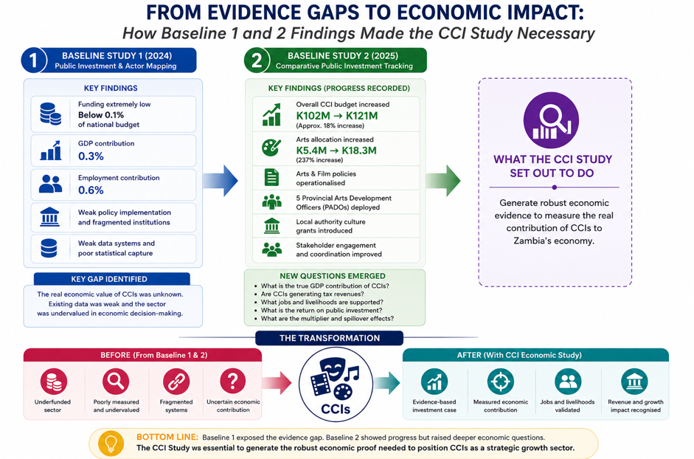
However, the Zambian literature exhibits three critical gaps.
- First, there is a lack of comprehensive economic valuation of CCIs. Existing estimates of GDP contribution (approximately 0.3 percent) are derived from aggregated national accounts that do not disaggregate creative activities or account for informality.
- Second, there is limited analysis of multiplier effects and cross-sectoral linkages. The extent to which CCIs stimulate activity in tourism, ICT, manufacturing, logistics, and services remains largely unexplored.
- Third, informal and digital creative activity — which constitutes a significant share of Zambia’s creative economy — is almost entirely absent from official statistics and academic analysis.

This study addresses these gaps by combining macroeconomic modelling with primary data collection and qualitative analysis, enabling a more accurate and policy-relevant assessment of CCIs’ economic contribution.

2.7 Conceptual Framework
The conceptual framework guiding this study positions CCIs as an integrated economic system embedded within national production, labour, and fiscal structures. It synthesises three complementary theoretical strands.
- First, Creative Value Chain Theory conceptualises CCIs as a sequence of interlinked activities — creation, production, distribution, and consumption — each generating value and employment. This perspective highlights the importance of infrastructure, market access, and distribution networks in scaling creative output.
- Second, Orange Economy and Creative Class Theory emphasise creativity as a source of innovation, competitiveness, and urban and regional development. These theories underscore the role of human capital, skills, and ecosystems in driving creative sector growth.
- Third, Cultural Satellite Account principles provide a macroeconomic lens for integrating cultural production into national accounts. Given Zambia’s data constraints, these principles are adapted rather than replicated, with proxy measures used to approximate value added, employment, and multipliers.

Crucially, the framework explicitly incorporates informality and digital production as structural features of Zambia’s CCIs. Public policy, financing, and institutional coordination are treated as catalytic inputs that influence productivity, scale, and sustainability. The framework thus links creative labour and intellectual property to economic outcomes such as GDP growth, job creation, household income, and fiscal revenue.

CHAPTER 3: METHODOLOGY

3.1 Methodological Rationale and Research Design

The chapter outlines the research design, data collection methods, and analytical frameworks employed to assess the economic contribution of Zambia's Cultural and Creative Industries (CCIs). A mixed-methods approach was used to triangulate findings, ensuring both quantitative rigor and qualitative depth.

This study adopted a mixed-methods research design to balance quantitative rigor with contextual depth. The complexity of the creative economy — characterised by informality, fragmented value chains, and non-standard modes of production — renders single-method approaches inadequate. Quantitative methods alone risked undercounting creative activity, while purely qualitative approaches lack macroeconomic credibility.

By integrating quantitative and qualitative methods, the study ensures analytical robustness, triangulation, and policy relevance.

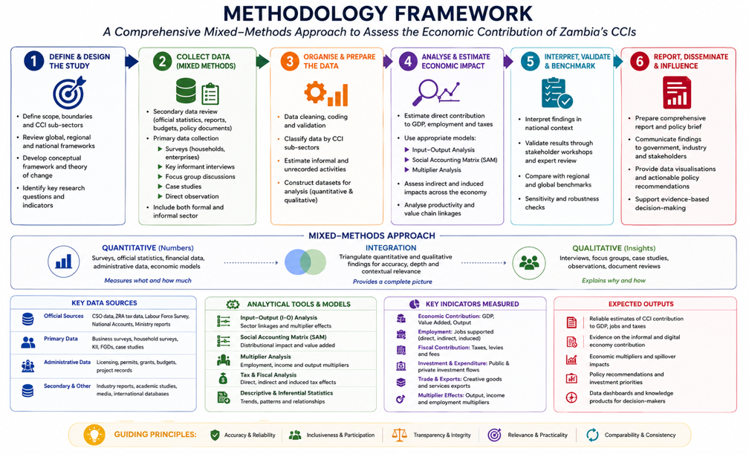

Research Design

A sequential exploratory mixed-methods design was adopted. This involved a qualitative phase with initial key informant interviews and focus group discussions to understand the landscape, identify key variables, and inform the design of the quantitative survey. The quantitative phase involved a broad-based survey to collect measurable data on economic activity, employment, and revenue.

Our analysis also involved the integration and interpretation of the qualitative data from later-stage key informant interviews and case studies to explain, contextualize as well as validate the quantitative results.

3.2 Data Sources

Secondary Data

The secondary data sources was also drawn from:
- Zambia Statistics Agency (ZamStats): GDP by industry tables, Labour Force Surveys, Household Income and Expenditure Surveys
- Zambia Revenue Authority (ZRA) data on levy and tax contributions (where available under confidentiality)
- National budget documents and Yellow Books (2019–2025)
- National Development Plans and sectoral policies
- Reports from the National Arts Council and industry associations
- Connect for Culture reports
- The Bank of Zambia (BoZ) data on export earnings from services
- Regional and international datasets from UNCTAD, UNESCO, ILO, and the African Union
These sources provide historical trends, benchmarks, and structural parameters for modelling.

Primary Data

Primary data is collected to address gaps in official statistics, particularly regarding informal and digital creative activity. Data collection methods include:
- Structured surveys targeting creative enterprises and practitioners
- Key Informant Interviews (KIIs) with policymakers, regulators, and sector leaders
- Focus Group Discussions (FGDs) with informal creatives, youth, and women-led groups

3.3 Sampling Strategy

The data was collected from multiple sources to ensure it is comprehensive. The Primary Data was be drawn from the key informant interviews through semi-structured interviews with 25-30 purposively selected stakeholders, including; Policymakers (Ministry of Youth, Sport and Arts, Zambia Revenue Authority -ZRA), Regulatory bodies (National Arts Council - NAC, Zambia Intellectual Property Office - ZIPO), Industry association leaders in music, film, fashion, financial institution representatives and successful creative entrepreneurs.

The research Focus Group Discussions (FGDs) involved 6-8 FGDs (8-10 participants each) conducted across three (3) provinces (Lusaka, Copperbelt, Southern) with grassroots creatives to capture challenges, informal sector dynamics, and gendered experiences. Provinces are selected based on documented concentration of creative activity and institutional presence. Snowball sampling was used to access informal and digitally based creatives who are typically excluded from formal registers. The sampling frames were drawn from association databases, event registries, and social media listings, with stratification by subsector, size (micro, small, medium), and location.

3.4 Economic Model: Enterprise and Economy-Wide Analysis
To structure the analysis, the study applied a simplified two-level economic model that links enterprise performance to economy-wide impacts.

At the enterprise level, a basic performance model was used to examine factors associated with stronger economic outcomes among creative enterprises. Performance is proxied using indicators such as annual revenue, output levels, or employment size. The model explored how enterprise outcomes are associated with digital adoption, access to finance, formality status, skills and experience, and subsector characteristics. At this draft stage, the model is used to identify patterns and relationships rather than to establish causal effects.

At the economy-wide level, the study applied the Zambia Social Accounting Matrix (Z-SAM) to estimate the broader economic effects of CCIs. Because CCIs are not explicitly disaggregated in national accounts, the model used proxy allocations from labour, household, and enterprise data to approximate creative sector activity. The Z-SAM framework was then used to estimate direct effects within CCIs, indirect effects through supplier linkages, and induced effects arising from

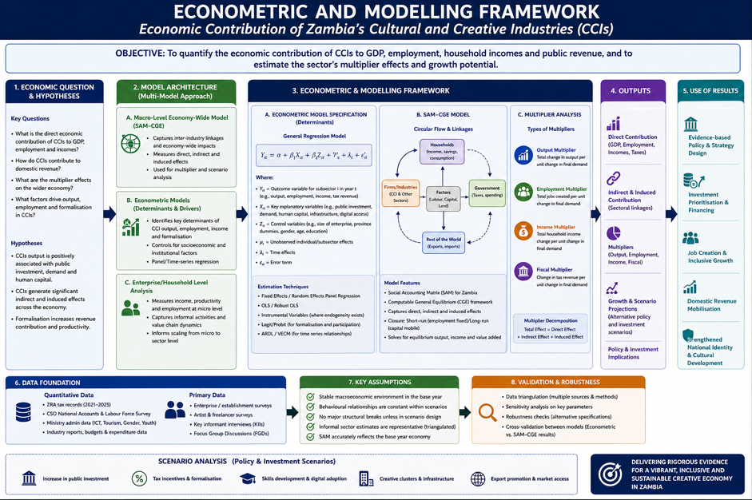

Econometric Model

Model Specification: To identify and quantify the determinants of economic success within CCIs, a multiple regression model will be estimated.

Proposed Econometric Model
Creative_Enterprise_Performance_i = β0 + β1(Digital_Adoption_i) + β2(Access_to_Finance_i) + β3(Formality_Status_i) + β4(Human_Capital_i) + β5(Subsector_Dummy_i) + ε_i

Where: Creative_Enterprise_Performance_i could be measured as Log (Annual Revenue) or Employment Size of enterprises.
β0: Constant.
β1-β5: Coefficients to be estimated, showing the marginal effect of each factor.
ε_i: Error term.

Key Variables for Analysis
Dependent Variables
- Direct Economic Contribution: CCI Gross Value Added (GVA), Gross Output.
- Employment: Number of full-time, part-time, and casual jobs generated by CCIs.
- Fiscal Contribution: Total levies, taxes (Corporate Income Tax, PAYE, VAT) paid to the Government
- Export Earnings: Revenue from cross-border sales of creative goods and services.

Independent & Moderating Variables:
- Firm Size & Maturity (years in operation).
- Formality Status (registered vs. informal).
- Digital Adoption Level (use of online platforms for creation, distribution, sales).
- Access to Finance (loans, grants, investor funding).
- Geographic Location (Urban vs. Rural, Province).
- Demographics of Practitioner (Age, Gender, Education Level).

Analytical Framework and Techniques

The study utilised the Descriptive & Inferential Statistics to summarise survey data, establish frequencies, means, and test for relationships between variables using chi-square, t-tests, ANOVA.
- Input-Output (I-O) Analysis & Social Accounting Matrix (SAM) Multiplier Analysis to quantify the total (direct, indirect, and induced) economic impact of CCIs. The Zambia Social Accounting Matrix (Z-SAM) model was used to calculate:
  - Output Multipliers: The total increase in economic output across all sectors from a unit increase in CCI final demand.
  - Income Multipliers: The increase in household income generated.
  - Employment Multipliers: The number of jobs created economy-wide per job/million ZMW in the CCI sector.
  - Ordinary Least Squares (OLS) regression was used, with diagnostic tests for multicollinearity, heteroskedasticity, and model fit.

- Key Informant Interview and FGD transcripts were coded and analyzed using Eviews and R softwares to identify recurring themes, challenges, opportunities, and policy insights.

Why the Methodology Is Important

  - Looking at the past researches, the traditional methods failed to capture informal and digital creative activity picture.
  - Quantitative methods alone would underestimate the sector
  - Qualitative methods alone lack macroeconomic credibility
  - Triangulation improves validity, depth, and policy relevance

3.6 Ethical Considerations and Limitations

The study faced challenges in capturing the full extent of the informal economy. Sampling may have coverage biases and the data gaps in official statistics required estimations and assumptions, which was clearly stated. The SAM-based multipliers are economy-wide averages and may vary at the subsector level.

The core analytical tool is the Zambia Social Accounting Matrix (SAM), which captures inter-sectoral flows within the economy. As CCIs are not disaggregated within the SAM, the study applies a structured imputation strategy using labour and household survey data to isolate creative sector activity. Input–output and multiplier analysis are used to estimate direct, indirect, and induced effects of CCIs on output, employment, and income.

All data collection adheres to ethical standards, including informed consent, confidentiality, and gender-sensitive facilitation.

CHAPTER 5. POLICY, LEGISLATIVE, INSTITUTIONAL, AND FINANCING ENVIRONMENT

5.1 Policy and Legal Framework Analysis

The legal and policy environment governing Zambia’s Cultural and Creative Industries (CCIs) is anchored in the Constitution, which establishes the foundational principles of democracy, human rights, good governance, and inclusive development. Constitutional guarantees such as freedom of expression (Article 20), freedom of association (Article 21), and citizen participation in national affairs provide the normative basis for creative production, artistic organisation, and cultural participation. These provisions affirm the state's obligation to respect, protect, and promote cultural expression as part of Zambia’s broader socio-economic transformation agenda.

While the Constitution does not explicitly define culture as a justiciable socio-economic right, its guiding values—human dignity, equity, social justice, and accountability (Article 8)—provide both the legal and moral justification for public investment in culture as a development sector. However, the absence of explicit recognition of cultural rights as enforceable economic and social rights has constrained the translation of constitutional principles into binding fiscal and policy obligations. This gap has effectively positioned culture as a discretionary policy domain rather than a strategic economic priority.

Zambia has, nonetheless, made notable policy advances in recent years. The National Arts Policy (2023) represents the most comprehensive attempt to reposition the arts as a driver of employment, innovation, and national identity. The policy articulates a vision of an inclusive and sustainable arts sector, emphasising capacity development, artists’ welfare, market expansion, digital innovation, and institutional coordination. It aligns Zambia’s cultural governance with continental and global commitments, including the African Union’s Agenda 2063 and the UNESCO 2005 Convention on the Protection and Promotion of the Diversity of Cultural Expressions.

Despite its progressive orientation, the Arts Policy remains weakly operationalised. It lacks clearly defined financing instruments, enforceable implementation regulations, and effective decentralisation mechanisms. While the policy acknowledges the economic potential of creative industries and public–private partnerships, the absence of dedicated budget lines, incentive frameworks, and subnational implementation modalities has limited its impact. Consequently, the policy’s ambitions have yet to translate into measurable economic outcomes.

Similarly, the National Film Policy (2023) positions film as both a cultural and economic sector capable of generating employment, promoting national branding, and stimulating technological innovation. It addresses critical enablers such as infrastructure development, professional training, digital transformation, and incentives for production. However, the policy’s economic potential remains unrealised due to limited fiscal allocation, weak inter-ministerial coordination—particularly with ministries responsible for technology, trade, and finance—and the absence of a Film Fund or fiscal incentives to attract private investment. If fully operationalised, the Film Policy could catalyse a competitive audiovisual industry with strong export potential and measurable GDP contributions.

The National Culture Policy (2003) remains historically significant as Zambia’s first comprehensive cultural policy and has recently undergone a review process initiated in 2025. While the policy established culture as a pillar of human development and strengthened heritage institutions, its scope has become outdated. It inadequately addresses contemporary creative subsectors such as digital content creation, fashion, gaming, and platform-based cultural production. A harmonised policy framework—integrating the 2003 Culture Policy with the 2023 Arts and Film Policies—would provide a unified Cultural and Creative Industries Policy, balancing heritage protection with modern creative enterprise development.

From a legislative perspective, the National Arts Council of Zambia Act (1994) and the National Heritage Conservation Commission Act (1989, amended 1994) continue to provide the statutory foundation for cultural governance. However, both statutes require substantial reform. The NAC Act confers regulatory and coordination responsibilities but lacks provisions for financial autonomy, investment mobilisation, decentralised governance, and integration with local government systems. The ongoing review of the Act presents a strategic opportunity to reposition NAC as a developmental institution capable of administering grants, mobilising creative finance, coordinating regional clusters, and supporting creative infrastructure.

Similarly, the NHCC Act requires updating to address contemporary challenges such as climate resilience, community participation, illicit trafficking of cultural property, and stronger integration with tourism and creative enterprise policies. Aligning heritage legislation with economic development frameworks would significantly enhance heritage’s contribution to employment and local economic development.

Across the policy and legal landscape, the most persistent gap is policy coherence and financing alignment. Arts, film, heritage, and creative enterprise frameworks operate largely in silos, with no unified investment strategy or coordinating mechanism. Budget allocations to culture remain below 0.1% of the national budget—far below the African Union’s 1% benchmark—undermining the implementation of otherwise progressive policies. Without harmonisation, resourcing, and decentralisation, policy ambition continues to outpace execution.

5.2 Institutional Environment
Zambia’s institutional architecture for CCIs comprises a network of ministries, statutory bodies, and semi-autonomous agencies responsible for heritage preservation, arts promotion, creative enterprise development, and cultural diplomacy. The Ministry of Youth, Sport and Arts (MYSA), through its Department of Arts, serves as the primary policy custodian for the sector. It oversees the implementation of the National Arts and Film Policies and supervises statutory bodies such as the National Arts Council of Zambia (NAC).

While the institutional framework is comprehensive on paper, its effectiveness is constrained by overlapping mandates, weak coordination, and limited fiscal decentralisation. MYSA’s broad portfolio—combining youth, sports, and arts—results in the arts and culture component receiving the least policy attention and budgetary allocation. The absence of a dedicated Creative Economy Unit or inter-ministerial coordination mechanism linking culture with finance, education, ICT, trade, and tourism has reinforced administrative siloing.

NAC plays a pivotal coordination role between government and creative practitioners through the various associations. However, chronic underfunding, limited staffing, and restricted statutory authority have curtailed its effectiveness, particularly at provincial and district levels. Although the appointment of Provincial Arts Development Officers (PADOs) marks progress, uneven geographic coverage and limited fiscal authority continue to constrain decentralised implementation.

Parallel institutions, including the National Heritage Conservation Commission and the National Museums Board, play vital roles in heritage preservation and education. Yet limited resources, weak integration with creative industry programming, and insufficient coordination among institutions have prevented the emergence of a cohesive Creative and Cultural Industries ecosystem.

Civil society organisations and private creative hubs have increasingly filled institutional gaps. Organisations such as PAAGZ, Barefeet Theatre, Modzi Arts, and BongoHive have contributed significantly through training, advocacy, research, and creative incubation. Under the Connect for Culture Africa (CfCA) initiative, multi-stakeholder collaboration has emerged as a promising governance model, demonstrating how co-governance between state and non-state actors can strengthen accountability, participation, and innovation.

5.3 Financing Environment

The financing environment remains the most binding constraint on the growth of Zambia’s creative economy. Public investment in CCIs has remained persistently low, with allocations embedded within MYSA’s budget and consistently below 0.1% of national expenditure. Although nominal allocations increased between 2019 and 2024, these increments remain negligible relative to GDP and domestic revenue, resulting in a persistent mismatch between policy ambition and fiscal commitment.

The absence of a dedicated statutory financing mechanism—such as a National Arts or Creative Industries Fund—has significantly weakened sectoral financing. NAC’s reliance on recurrent grants and donor-supported projects undermines predictability, limits provincial outreach, and constrains innovation. At the subnational level, occasional use of the Constituency Development Fund (CDF) for cultural activities remains ad hoc and lacks strategic alignment with national cultural objectives.

Private-sector investment remains limited due to weak incentives, absence of risk-sharing mechanisms, and limited economic data to demonstrate returns. Corporate sponsorship of events is largely episodic, with little long-term investment in creative enterprises or infrastructure. Similarly, donor support has been largely project-based, resulting in cyclical funding patterns that do not strengthen systemic capacity.

Despite these challenges, reform opportunities exist. The review of the NAC Act and institutional restructuring within MYSA provide an entry point for establishing a Creative Industries Financing Mechanism capable of mobilising public seed funding, private investment, and donor co-financing. Integrating CCIs into national development planning frameworks and borrowing instruments would further enable cross-sectoral budget allocations.

5.4 Strategic Implications
Zambia’s policy and institutional frameworks for CCIs are no longer the primary constraint; execution, coherence, and financing are. Strengthened legislation, effective decentralisation, predictable financing, and inter-ministerial coordination are essential to reposition culture as a pillar of economic diversification. If these reforms are realised, CCIs could evolve into a robust ecosystem that generates employment, supports youth livelihoods, strengthens national identity, and contributes meaningfully to GDP growth.

CHAPTER 6: Contribution of the Cultural and Creative Industries to Domestic Revenue Mobilization

6.1 Introduction: Arts, Culture, and Domestic Revenue Mobilization
Domestic revenue mobilisation remains a central pillar of Zambia’s economic reform and fiscal sustainability agenda, particularly in a context of constrained fiscal space, rising development needs, and ongoing efforts to reduce reliance on external borrowing. Within this landscape, policy attention has traditionally focused on extractives, agriculture, manufacturing, and large-scale services as the primary sources of tax revenue. Cultural and creative industries (CCIs), by contrast, have often been perceived as socially valuable but fiscally marginal sectors, more commonly associated with public expenditure than with revenue generation.

This chapter challenges that perception by examining administrative tax data from the Zambia Revenue Authority (ZRA) to assess the actual contribution of arts and culture to domestic revenue mobilisation. Unlike perception-based assessments or indirect estimates, tax records provide concrete evidence of realised economic activity within the formal economy. As such, they offer a robust and conservative basis for evaluating the fiscal relevance of the creative sector and its evolving role within Zambia’s tax base.

6.3 Overview of Zambia Tax Performance between 2021 and 2025

Zambia has undertaken tax reforms which have seen the total contribution of tax revenue steadily rising. Since the covid-19 period of 2020, tax revenues have steadily increased rising from K53.2 billion representing 44.5 percent of the budget (14.5 percent of GDP) in 2021 to K165.8 billion representing 65.5 percent of the budget (17.9 percent of GDP) in 2026 (Zambia National Budget Speech Address, 2021, 2026). Several policy interventions have attributed to this including tax payer education and sensitisation programmes, efficiency in tax collection methods through improved technology, collaborations with other government and public entities in the enforcement of taxpayers to comply with tax payments, sustained economic growth which has resulted in the economy growing at an average of 5.2 percent over the five year period since 2021 and amnesty and waivers offered to taxpayers with long outstanding debt to the authority, among others have attributed to this performance.

6.4 The Creative and Arts Sector Performance on Tax 2021 to 2025

The creative and art sector has played its part in terms of contribution to the national cake, for instance in 2021, the sector contribution (K160.9 million) to the total taxes collected by ZRA of K53.2 billion represented 0.3 percent. By 2025, the sector contribution in terms of tax amounting to K833.6 million increased to 0.5 percent of the total collections of K165.8 billion. The sector over the last years recorded absolute growth in terms of tax collections from K160.9 million to K833.0 million. This amount represents a nominal growth rate of 520 percent.

6.5 Creative and Art Sector Contribution disaggregated by Tax Type

In terms of contributions of the sector by tax type, there are 10 tax types that the sector participates in or contributes to the national treasury. These are listed as: Gaming and Betting Tax, Income Tax, PAYE, Presumptive Tax, Property Transfer Tax, Rental Income Tax, Tourism Levy, Turnover Tax, VAT and Withholding Taxes. Out of these tax types the three most important taxes contributing almost 40 percent of the total collections that the sector adds are Withholding Tax, VAT and PAYE. Corporate Income Tax rates as the fourth most important tax.

This trend where most of the sector exists more as an informal sector depending more on income from shows, festivals, performances, exhibitions etc and one-off activities is expected and hence the realisation of the majority of the income from the sector through Withholding taxes and Value Added Taxes. Further, as the sector exhibits less formalised companies, small to medium sized enterprises and mostly sole trading companies the trend is expected that the collections from PAYE will be limited as many small companies may not either register for PAYE for all the employees, or express low levels of compliance on PAYE, as they suffer to fight existence with the increasing cost of production.

The WHT depends on the levels of compliance of the entertainers as the formal organisers/promotors will withhold and submit to government, and if the performer is compliant this will be netted out to determine the full tax liability of the taxpaying creative art member. The trend would expect a high level of contribution attributed to Corporate Income Taxes as the sector grows and bigger firms emerge to replace withholding taxes and turnover taxes as the most important income taxes. For VAT, the sector falls under the entertainment sector, where VAT is charged for the supply of entertainment services.

The Income tax Act has also been amended to provide for the taxation through presumptive tax for the creative and art sector participating taxpayers through especially the digital entertainment platforms. Albeit, the level and number of registered taxpayers is still very small, sitting at only 8 as in 2024.

Progression of the Creative and Art Sector Registration by Tax Types
Over the five-year period, the number of registered participating taxpayers under the sector has remained highest under the PAYE, followed by TOT and then the WHT at 10,067, 6,880 and 3,308 respectively. Of critical importance is the observation that the trend for registration of the taxes overall is increasing narrated by good impact of tax administration through compliance efforts. On the other hand, there is a remarkable reduction in the WHT registration while ToT is on the upswing partly due to tax policy trends at making the TOT more affordable so as to increase the level of compliance.

Beyond gaming and betting, the growth of Pay As You Earn (PAYE), value added tax (VAT), and withholding tax provides deeper insight into the evolving economic structure of CCIs. PAYE collections increased from ZMW 26.5 million in 2021 to ZMW 85.9 million in 2024, alongside a rise in PAYE-registered taxpayers from 1,881 to 3,146. This trend demonstrates that the creative sector is not only generating self-employment and informal livelihoods but is increasingly functioning as a source of formal wage employment. The implication is critical for policymakers: investments in CCIs should be understood as labour market interventions with tangible implications for income tax mobilisation and household welfare.

6.6 Progression of the Creative and Art Sector Registration by Tax Types and Tax Revenue Collections

Table 1 is a summary of the number of taxpayers under each category and the amount of taxes collected from them between 2021 and 2024 for the creative and art sector between 2021 and 2024 as provided by the ZRA. This simultaneous growth in both revenue and taxpayer numbers is analytically significant. It suggests that the observed increase is not merely the result of enforcement measures or tax rate changes but reflects a broader process of sectoral expansion and gradual formalisation. In public finance terms, the creative economy is evolving from a marginal tax contributor into an increasingly visible and structured component of the national tax base.
A closer examination of the composition of tax revenues reveals important structural characteristics. The largest share of collections is derived from gaming and betting tax, which increased sharply from ZMW 71.0 million in 2021 to nearly ZMW 406.0 million in 2024.

Table 1: Creative and Arts Revenue contributions

Year | 2021 |  | 2022 |  | 2023 |  |  | 2024
Tax type | No. of Taxpayers | Tax revenue | No. of Taxpayers | Tax revenue | No. of Taxpayers | Tax revenue | No. of Taxpayers |  | Tax revenue
Gaming and Betting Tax | 366 | 70,974,743.0 | 566 | 155,238,023.4 | 605 | 265,301,352.9 | 578 |  | 405,957,459.9
Local Excise -Non-Alcoholic Beverages | - | - | 2 | 9,000.04 | - | - | - |  | -
Income Tax | 120 | 2,350,374.2 | 133 | 171,808.1 | 205 | 13,511,144.2 | 275 |  | 23,150,766.5
Pay As You Earn | 1,881 | 26,497,083.1 | 2,210 | 45,213,838.8 | 2,830 | 91,900,457.7 | 3,146 |  | 85,879,153.3
Presumptive Tax | 1 | 1,350.0 | 8 | 9,450.0 | 7 | 10,800.0 | 11 |  | 8,050.9
Property Transfer Tax | 16 | 1,035,930.8 | 11 | 267,666.7 | 17 | 11,687,958.2 | 13 |  | 3,273,524.9
Rental Tax | - | - | - | - | 206 | 1,034,400.4 | 261 |  | 2,460,630.5
Tourism Levy | 322 | 1,267,794.2 | 326 | 2,385,299.6 | 365 | 2,636,317.2 | 522 |  | 4,300,320.0
Turnover Tax | 1,170 | 1,750,775.6 | 1,389 | 1,622,022.9 | 1,950 | 2,686,619.2 | 2,371 |  | 2,977,826.6
Value Added Tax | 472 | 27,626,646.6 | 614 | 58,645,206.1 | 714 | 90,230,375.2 | 738 |  | 123,970,416.4
Withholding Tax | 1,143 | 29,446,191.6 | 706 | 100,994,078.2 | 655 | 143,949,255.9 | 804 |  | 180,817,549.2
Grand Total | 5,491 | 160,950,889.1 | 5,965 | 368,556,393.6 | 7,554 | 622,948,680.8 | 8,719 |  | 832,795,698.1

6.7 The Creative and Arts Sector Contribution by Sub Sector 2021 to 2025

On the overall the total registered taxpayers under the sub sectors increased from 3,154 to 6,535 over the five-year period, a growth of 75 percent, see table 2 below. The sub sector that recorded the largest increase in terms of the number of taxpayers in the five-year period is the film by 175 percent, whereas Designing increased by 157 percent and Culture & Heritage 136 percent. Radio and TV programming also increased by 55 percent. On the negative side was the music sub sector that reduced the number of taxpayers by 6 percent. Radio and TV programming is performing partly on the back of formal arrangements with also the coming in of productions under the entertainment sector such as multi-choice and other local TV stations that have expanded the number of local programmes on TV.

The increased revenue in VAT patterns suggest that CCIs are becoming more deeply embedded within formal value chains, supplying services to businesses, advertisers, broadcasters, and public institutions. In this sense, the creative economy increasingly resembles a commercial services ecosystem, rather than a collection of isolated artistic activities.

Subsector-level analysis further illustrates both the strengths and imbalances within the current fiscal profile. Radio and television programming accounts for the overwhelming majority of recorded creative-sector tax revenue, generating between ZMW 366 million and ZMW 476 million annually during the period under review. This dominance reflects the maturity of the broadcasting industry, its advertising-driven revenue model, and relatively high compliance capacity.

The Revenue contribution expanded by 21 percent and this was mostly contributed by the radio and TV programming followed by culture and heritage. Design and Visual Arts increased collections by 539 percent. The table 2 below is a summary of this revenue contribution by sub sector as compiled by the ZRA.

Table 2: Revenue contributions by Sub-sector
Year | 2021 |  | 2022 |  | 2023 |  | 2024
Tax type | No. of Taxpayers | Tax revenue | No. of Taxpayers | Tax revenue | No. of Taxpayers | Tax revenue | No. of Taxpayers | Tax revenue
Film & Media production | 284 | 1,638,566.6 | 331 | 1,215,572.4 | 458 | 1,822,766.4 | 840 | 2,780,645.5
Design & Visual Services | 364 | 1,142,768.6 | 406 | 2,974,133.4 | 707 | 5,131,565.3 | 946 | 7,798,929.6
Music production & recording | 48 | 58,437.8 | 50 | 56,502.0 | 58 | 48,247.8 | 45 | 28,323.4
Cultural & Heritage | 1,058 | 7,102,802.4 | 1,169 | 11,417,266.3 | 1,942 | 26,964,453.1 | 2,499 | 41,108,301.7
Radio & Television programming | 1,448 | 366,193,277.8 | 1,587 | 378,044,014.2 | 1,839 | 475,648,369.0 | 2,250 | 405,684,479.7
Grand Total | 3,154 | 376,077,415.3 | 3,493 | 393,650,986.3 | 4,946 | 509,567,153.7 | 6,535 | 457,372,356.5

6.8 Breaking the Barriers and Improving the Industry Contribution

The challenges identified to maximising the revenue collections include non-compliance especially in the informal sector, tax evasion and tax avoidance. The sector is still small in terms of contribution to national taxes including in comparison to other countries and greatly attributed to the large informalisation of business under the sector. Digitisation of the economy still requires that the informal creative and art be empowered with the necessary technology through insentivisation through tax policy especially with the tools that they use to perform digital creativity. Increased advocacy campaigns also on the advantages attributable to tax compliance especially when it comes to accessing government contracts, empowerment facilities and other businesses need to be spelt out to the artists in order that they do not lose out on potentially these government programmes.

From table 2 above, while broadcasting provides a stable fiscal anchor for the sector, it also masks the economic potential of other creative subsectors that remain under-represented in tax collections.
Cultural and heritage activities present a contrasting picture. Although their absolute contribution remains modest relative to broadcasting, revenue from this subsector increased more than fivefold between 2021 and 2024, while the number of registered taxpayers more than doubled. This pattern indicates that when creative activity is linked to identifiable assets, locations, and tourism flows, formalisation becomes more feasible. The growth of heritage-related tax revenue therefore signals an opportunity to strengthen domestic revenue mobilisation through better integration of cultural tourism, local government financing, and community-based enterprises.

Design and visual services also demonstrate a strong and consistent growth trajectory. Tax revenue from this subsector increased nearly sevenfold over four years, accompanied by a sharp rise in taxpayer registration. This aligns with broader digitalisation trends and the expansion of branding, advertising, and creative services across the economy. From a fiscal perspective, design and visual services represent a scalable and relatively low-risk revenue pathway, as they are already integrated into formal business transactions and digital invoicing systems.

In contrast, film, media production, and music exhibit persistently low recorded tax contributions relative to their perceived economic and cultural significance. Film and media production shows gradual revenue growth alongside increasing taxpayer numbers, suggesting low average earnings per enterprise and project-based income volatility. Music production and recording remains the lowest contributor, with recorded revenues declining by 2024. This should not be interpreted as evidence of low economic activity. Rather, it reflects a structural mismatch between how value is created in these subsectors and how it is currently captured within the tax system. Income is often dispersed across freelancers, event-based engagements, informal venues, and digital platforms, many of which fall outside conventional reporting and classification frameworks.

From a macroeconomic perspective, the ZRA data captures only the direct fiscal effects of creative activity. It does not account for indirect effects through supplier networks, nor induced effects arising from household consumption of creative-sector incomes. Social Accounting Matrix (SAM) analysis presented in this report demonstrates that sectors with strong labour intensity and service linkages tend to generate significant economy-wide spillovers. As such, the tax revenues observed here likely understate the creative economy’s full contribution to public finances when multiplier effects are taken into account.

6.9 Non-Tax Performance of the Arts and culture
The main contributions to the non-tax revenue collections for the Treasury, arise from company registrations and registration of copyrights under the Patents and Companies Registration (PACRA).

There was a challenge to collect the data on the amounts of revenue collected as company registration from the CCI sector. This was attributed to the inflexibility of the system the institution was utilising to disintegrate data to the sector level whereby the revenue received from music, film, visual, etc. could be isolated.

Non-Tax Revenue Collections from the Registration of Copyrights under PACRA
As at the time of the report, the data that was available and shared was the collections from PACRA in respect of registration of copyrights from 1st January 2025 to 19th December 2025. The data for the period 2021 to 2024, was still being compiled and was advised to be available within the first week of January 2026 which unfortunately was not collected to help in developing this report.

Based on the collections for 2025, the total revenue collected was contributed by 181 registrations of copyrights by the sector players, with each registration charged at K500. Therefore, the total collections amounted to K90,500. As highlighted, the full contribution of collections for 2021, 2022, 2023 and 2024, was not obtained to get a trend as to the activities in the sector for more detailed analysis.

6.10 Challenges of Impacting the Revenue Contribution on Non-Tax Revenue by the CIC Sector
- Voluntary Nature of Registration of Copyrights
The revenue raised from copyrights registration is dependent on the number of artists that voluntarily decide to come forward on their own to register copyrights for their work. This number does not reflect the “amount of actual pieces of work produced in the year by the artists”. This presents a potential revenue gap as there is no law in Zambia available to compel every artist that produces works to register it for copyrights. To get an indication on the extent of the leakage, the registered copyrights in 2025 of 181 were matched against the total number of taxpayers in the sector in the year 2024 of 6,535, based on the Zambia Revenue Authority (ZRA) data. If an artist produces one piece of work every two years and registers the copyrights for each production, that would give 3,268 potentially registerable, copyrights. At K500, per registration, this would result in an 18-fold increment in the revenue collected annually by the Treasury from the CCI sector to K1.6 million from K90,500.

The informal and “gig-based” nature of much activity in the Music subsector, coupled with weak royalty collection and limited copyrights enforcement means many creators rely heavily on performances and brand deals rather than recorded music revenues. This structurally skews earnings and limits formal enterprise and subsequently economic growth. While copyright protection is automatic, registration provides a public record of your copyright. This can be crucial in the event of a copyright dispute. Copyright registration also provides proof of ownership. This can be especially important if you plan to sell or license your work. With a registered copyright, you can easily prove that you are the original creator of the work. Copyright registration allows you to take legal action against copyright infringement. If someone uses your work without your permission, you can sue them for damages. Without a registered copyright, you may not be able to take legal action. With a registered copyright, you can license your work to others for a fee. This can provide a significant source of income, especially for artists, writers, and musicians.

- Lack of Awareness of the Benefits
There are benefits that accrue to the individuals and the country as a whole associated with the registration of copyrights. At the very least, copyrights provide an aid to commerce through the sale of these rights both locally and internationally and provide a source of income to the persons registering the copyrights which has an impact on the GDP. This actually depends on the ability to have legal protection from your work. However, there is a lack of awareness on the benefits accruing among the potential beneficiaries who are the producers of works that are registerable for copyrights. Therefore, there is a need to break the barriers to this challenge.

While copyright protection is automatic, registration provides a public record of your copyright and legal protection. This can be crucial in the event of a copyright dispute. Copyright registration also provides proof of ownership. This can be especially important if you plan to sell or license your work. With a registered copyright, you can easily prove that you are the original creator of the work. Copyright registration allows you to take legal action against copyright infringement. If someone uses your work without your permission, you can sue them for damages. Without a registered copyright, you may not be able to take legal action. With a registered copyright, you can license your work to others for a fee. This can provide a significant source of income, especially for artists, writers, and musicians.

6.11 Key Fiscal Findings for Policymakers and implications
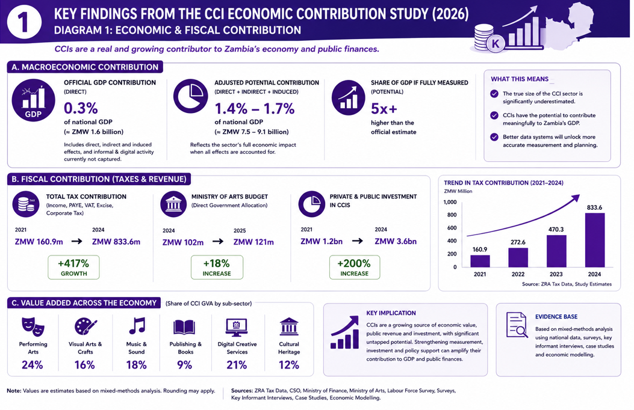
The administrative tax data confirms that Zambia’s cultural and creative industries are already making a meaningful contribution to domestic revenue mobilisation, with collections rising rapidly between 2021 and 2024 alongside a broadening tax base. However, the fiscal profile of the sector is highly concentrated in a few subsectors, particularly gaming, betting, and broadcasting, creating both opportunities and vulnerabilities. At the same time, fast-growing but under-monetised subsectors such as heritage, design services, film, and music reveal substantial untapped fiscal potential. The evidence suggests that revenue growth is most sustainable when driven by formalisation, market development, and improved classification, rather than punitive enforcement. Aligning tax policy with creative industry development strategies would therefore allow Zambia to expand its revenue base while supporting employment, enterprise growth, and economic diversification.

The central policy challenge is not whether the creative sector can contribute to public revenue—it already does—but how to broaden and stabilise that contribution. Diversifying the tax base beyond betting and broadcasting, improving the alignment between creative value creation and tax instruments, and supporting simplified compliance pathways for freelancers and micro-enterprises would enhance both revenue performance and sector sustainability. Strengthening heritage-linked tourism financing, clarifying the treatment of digital creative earnings, and integrating creative industries more explicitly into national development and revenue strategies would allow Zambia to harness the creative economy as a resilient and inclusive source of domestic revenue.

CHAPTER 7: SUBSECTOR ANALYSIS OF ZAMBIA’S CULTURAL AND CREATIVE INDUSTRIES and financial contribution

7.1 Analytical Framing and Data Sources

This chapter disaggregates Zambia’s Cultural and Creative Industries (CCIs) into key subsectors to illuminate how value is created, who benefits, and where constraints occur. While macroeconomic modelling estimates aggregate contributions, subsector analysis reveals the microeconomic mechanics that shape employment, income distribution, and multiplier effects.
Findings in this chapter draw on:
- Enterprise and practitioner surveys,
- Key informant interviews (KIIs) with artists, associations, regulators, and promoters,
- Focus group discussions (FGDs) with informal creatives,
- Administrative data from sector bodies, and
- Comparative benchmarks from African creative economy studies.

Unless otherwise stated, employment and income figures should be interpreted as indicative estimates, triangulated across multiple data sources.

This section also presents an analysis of the financial contribution of Zambia’s Cultural and Creative Industries (CCIs) derived from Focus Group Discussions (FGDs) and Key Informant Interviews (KIIs) conducted across selected provinces and creative sub-sectors. In the absence of a comprehensive cultural satellite account and given the high levels of informality within the sector, qualitative evidence was systematically analyzed and translated into financial projections to capture the scale, structure, and growth dynamics of creative economic activity.

Participants in FGDs and KIIs consistently described Zambia’s creative sector as a decentralized but economically viable industry, anchored in home studios, live performance markets, digital platforms, and a wide range of auxiliary services. Creative practitioners, producers, promoters, and policymakers emphasised that creative work is no longer marginal or purely cultural but constitutes a primary livelihood strategy for a growing number of urban youth and small-scale entrepreneurs. These narratives formed the basis for constructing conservative, analytically grounded estimates of financial contribution.

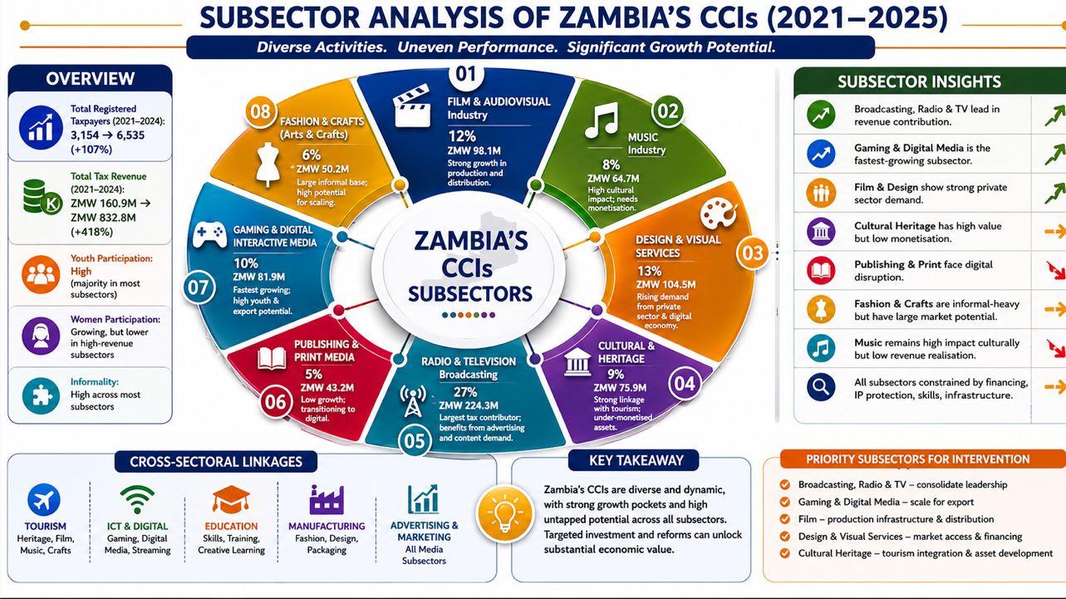

7.2 Comparative Subsector
Table 7.1: Comparative Economic Profile of CCI Subsectors (Indicative Ranges)
Subsector | Estimated Employment Intensity | Typical Income Pattern | Formality | Key Markets
Music | High (youth-led; project-based) | Highly unequal; performance-driven | Low–Medium | Live events, digital
Film & AV | Medium (skills-intensive) | Higher per project | Low–Medium | Broadcast, online, festivals
Fashion & Crafts | Very High (women-led) | Low–Medium; seasonal | Low | Tourism, retail
Publishing | Low–Medium | Supplementary incomes | Medium | Education, NGOs
Visual Arts | Low–Medium | Commission-based | Low–Medium | Galleries, donors
Heritage | Medium (place-based) | Low–Medium; community | Medium (public/community) | Tourism
Digital Media | Growing; volatile | Highly skewed | Very Low | Platforms, ads

7.2 Music Industry

The music industry is among the most economically active creative subsectors in Zambia. It is characterised by a dual structure: a small formal segment (record labels, broadcasters, event companies) and a large informal ecosystem of independent artists, producers, DJs, promoters, and live performers. While Lusaka dominates formal production, informal music economies operate across all provinces, embedded in weddings, churches, bars, festivals, and community events. Administrative records from rights management organisations suggest that only a minority of active musicians are formally registered, indicating substantial undercounting in official data.
“Most artists survive on performances, not royalties. Registration exists, but enforcement is weak, so many don’t see the benefit.”
— KII, Music Association member

Employment and Income Patterns- Survey and FGD data suggest that the music subsector supports tens of thousands of livelihoods, predominantly youth-led. Employment is largely informal and project based. Indicative monthly incomes range widely:
- subsistence-level performers earning irregular event fees,
- semi-professional artists earning stable income from performances and endorsements,
- a small elite capturing significant commercial returns.
Music also generates indirect employment in sound engineering, event logistics, transport, fashion, security, and media.

Across discussions, respondents identified four dominant revenue streams within the creative economy: live performances or shows/events, studio-based production services, digital distribution and content monetization, and supplementary creative services such as video production, branding, promotion, sound engineering, and logistics. While participants did not always articulate revenues in formal accounting terms, the consistency of income patterns reported across provinces allowed for triangulation and the development of plausible revenue ranges.

Live performance emerged in both FGDs and KIIs as one of the most visible and financially significant components of Zambia’s CCIs. Artists and promoters reported that performance fees vary widely depending on artist profile, location, and client type, but converge around a common range for commercially active musicians. Several respondents in provincial FGDs indicated that leading artists frequently receive fees equivalent to several thousand Kwacha per show, even outside Lusaka, with some reporting single-event earnings exceeding K15,000–K20,000. When synthesized and conservatively interpreted, these discussions suggest that a pool of approximately 200 commercially active artists performing an average of two paid shows per month at modest average rates would generate annual performance revenues in the region of K38 million nationally. Importantly, respondents emphasized that these figures exclude corporate events, international bookings, and festival circuits, implying that this estimate represents a lower-bound approximation.
Studio-based production services constituted the second major revenue stream highlighted across KIIs with producers and sound engineers. Participants repeatedly described the proliferation of home studios and semi-professional production units, enabled by declining costs of digital equipment and software. Producers reported earning steady monthly incomes from recording sessions, beat production, mixing, and mastering, with smaller studios generating several thousand Kwacha per month and larger ones significantly more. When these narratives are aggregated, a conservative estimate of approximately 600 active studios nationally, each generating around K5,000 per month, yields an annual studio economy of roughly K36 million. Respondents also noted that these figures exclude income from training, equipment resale, and software services, reinforcing the conservative nature of this projection.

Value Chain and Markets- The value chain spans composition, recording, distribution, and performance. Digital streaming platforms have expanded reach but capture a large share of value offshore. Live performances remain the most reliable revenue stream, reinforcing strong linkages with hospitality and nightlife economies.
“Streaming gives visibility, but it does not pay the bills. Shows are what keep us afloat.”
— FGD participant, Lusaka-based artist

Economic Linkages and Multipliers- Music exhibits high employment multipliers due to low capital requirements and strong household consumption effects. Within the SAM framework, music-related activities are expected to generate above-average induced effects through spending on transport, food, accommodation, and services.

Key Constraints and Opportunities- Constraints include weak IP enforcement, limited access to finance, and inadequate performance infrastructure. Opportunities lie in improved royalty systems, festival-based tourism, and export-oriented digital strategies, consistent with findings from UNESCO (2021) and WIPO (2015).

7.3 Film and Audiovisual Industry

The film and audiovisual subsector are smaller in scale but strategically important due to its capital intensity and export potential. It comprises a limited number of registered production companies, freelancers, and informal crews. Production is episodic and highly sensitive to access to finance and equipment.
“Skills exist, but funding gaps kill projects before they start.”
— KII, independent film producer

Employment and Income- Employment is project-based and skill-intensive, involving actors, directors, technicians, editors, and support staff. While overall employment numbers are lower than in music or crafts, average earnings per project are higher, reflecting skill and capital requirements. Informality remains prevalent among freelancers.

Value Chain and Market Access- The value chain includes development, production, post-production, and distribution. Distribution remains a major bottleneck due to limited cinema infrastructure and weak export channels. Broadcasters and online platforms dominate domestic distribution.

Linkages and Multiplier Effects- Film production stimulates demand across accommodation, catering, transport, and logistics, particularly during location shoots. Comparative African studies indicate that film has strong spatial multipliers, especially in tourism-linked locations (UNCTAD, 2022).

Constraints and Opportunities- Key constraints include lack of production finance, specialised skills, absence of fiscal incentives, and weak distribution. Opportunities exist through co-production agreements, location incentives, and integration into tourism branding strategies.

7.4 Fashion and Crafts

Fashion and crafts are among the most employment-intensive creative subsectors. They are dominated by micro-enterprises, cooperatives, and informal producers, many operating in rural and peri-urban areas. Women constitute a significant share of producers, particularly in crafts.
“This work feeds families, but it is not recognized as an industry.”
— FGD participant, women-led craft cooperative

Employment and Income- These subsectors provide critical livelihood support for low-income households. Employment is largely informal, with income levels influenced by seasonality, tourism flows, and market access. While individual earnings are modest, aggregate employment effects are substantial.

Value Chains and Markets- Value chains extend from raw material sourcing to production and retail. Weak branding, quality standardisation, and export access constrain value capture. Tourism markets offer the most immediate growth potential. Fashion and crafts generate strong local multipliers, particularly in rural economies, through backward linkages to agriculture and forward linkages to tourism and retail.

Constraints and Opportunities- Constraints include limited finance, design skills, and market information. Growth opportunities lie in cluster development, cooperative financing, and integration into cultural tourism circuits.

7.5 Publishing and Visual Arts

Publishing and visual arts intersect closely with education, heritage, and public procurement. Employment is fragmented and often supplementary, with artists combining creative work with teaching or other income sources.
“Books and art survive because of schools and donors, not markets.”
— KII, visual arts practitioner

Value Chains and Markets- Markets are narrow, dominated by educational institutions, NGOs, and public commissions. Copyright enforcement and market development remain weak. Although smaller in scale, these subsectors have high forward linkages to education and cultural diplomacy, suggesting underestimated economic and social returns.

7.6 Heritage and Cultural Tourism
Heritage-based activities are often publicly or community managed and linked to tourism destinations. Revenue capture at community level remains limited due to weak financing and governance mechanisms.

Employment And Local Multipliers- Heritage generates place-based employment and strong local multipliers, particularly in tourism-dependent districts. However, benefits are unevenly distributed.
“Tourists come, but little stays with the community.”
— FGD participant, heritage site committee

7.7 Digital Media and Content Creation

Digital media is a rapidly expanding but poorly measured subsector. Youth dominate content creation across social media, Podcast production, video, and online platforms. Formal registration is almost non-existent , and monetisation is inconsistent.

Income And Market Dynamics- Income is volatile and platform-dependent. While a small number of creators earn substantial revenues, most operate at experimental or subsistence levels. Despite measurement challenges, digital media has high future growth potential and strong linkages to ICT, advertising, and exports, consistent with ILO–AU findings on digital creative work.

Digital distribution and platform-based monetization emerged as an increasingly important, though unevenly captured, revenue source. Artists and producers described income streams from streaming platforms, downloads, YouTube monetization, and cross-platform promotion, although most acknowledged that digital revenues remain underreported and poorly documented. Nonetheless, respondents consistently indicated that successful tracks generate recurring incomes over several years. Synthesising these accounts suggests that if even a fraction of locally produced tracks generate modest annual digital earnings, total sector-wide digital revenues would conservatively exceed K6 million per year, excluding influencer partnerships, licensing, and international royalties.

When these three revenue streams are aggregated, the qualitative evidence suggests that the music sub-sector alone generates in excess of K80 million in direct annual revenues. Participants in FGDs were quick to emphasise that music represents only one component of the broader CCIs ecosystem, alongside film, fashion, crafts, design, publishing, heritage, and performing arts. Thus, respondents viewed the music economy as illustrative rather than exhaustive of the sector’s financial scale.

7.8 Comparative Subsector Insights
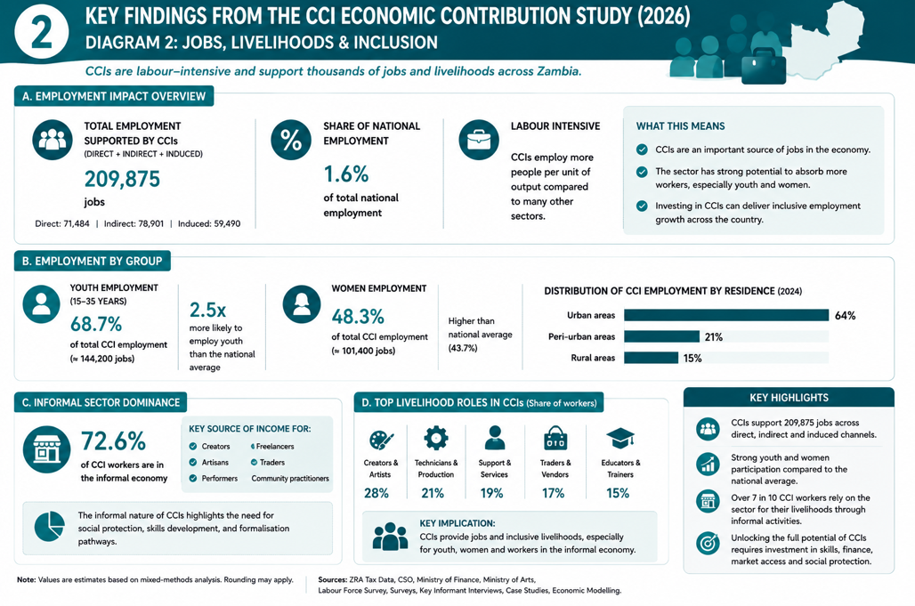

Across subsectors, four patterns emerge:
- Employment intensity exceeds capital intensity, reinforcing CCIs’ relevance for inclusive growth.
- Informality dominates, leading to systematic underestimation in national accounts.
- Value leakage is significant, particularly in digital markets.
- Public investment is catalytic, especially when it reduces risk and unlocks private finance.

Beyond direct revenues, respondents repeatedly highlighted the spillover effects of creative activity into other sectors. Artists and promoters described how performances stimulate hospitality, transport, catering, accommodation, and security services. Studio owners reported reliance on ICT services, electricity, hardware suppliers, and software vendors. These interdependencies confirm that CCIs operate as intermediary sectors transmitting financial flows across the urban economy rather than functioning in isolation. Applying a conservative multiplier consistent with service-sector characteristics, the qualitative evidence supports the conclusion that the total economy-wide impact of the music sub-sector alone exceeds K180 million annually when indirect and induced effects are taken into account.

Employment and income generation emerged as central themes across all FGDs and KIIs. Respondents consistently framed CCIs as major absorbers of youth labour, particularly in contexts of limited formal employment opportunities. Participants described layered employment structures involving performers, producers, dancers, videographers, promoters, managers, drivers, technicians, and informal traders. When translated into employment-output ratios consistent with service-sector benchmarks, the qualitative evidence suggests that the music economy alone sustains over 1,500 full-time equivalent jobs when multiplier effects are included. This excludes seasonal, part-time, and volunteer labour, implying that CCIs play a materially significant role in Zambia’s urban labour market.

From a fiscal perspective, KIIs with policymakers and local authorities underscored the growing, though still under-recognized, contribution of CCIs to domestic revenue mobilization. Respondents noted increases in business registration among creative enterprises, greater engagement with local authorities for event licensing, and rising PAYE and withholding taxes associated with studio employment and event management. When conservatively quantified, the qualitative evidence supports an estimate of over K7 million annually in direct tax contributions from the music sub-sector alone, with total fiscal impacts likely exceeding K15 million once indirect effects are considered.

Participants were also asked to reflect on the growth trajectory of CCIs. Across FGDs, respondents expressed strong optimism regarding the sector’s expansion, particularly driven by digitisation, regional markets, and youth entrepreneurship and labour. When these growth narratives are translated into conservative financial projections assuming annual growth of approximately 10 percent, direct revenues from the music sub-sector would rise from approximately K80 million to nearly K118 million within five years, with cumulative economy-wide impacts exceeding K1.1 billion over the same period. This projection reflects not speculative optimism, but the structural transformation described consistently across qualitative interviews.

Importantly, respondents were unequivocal that the primary constraints facing CCIs are not demand or talent, but financing, policy recognition, infrastructure, and institutional support. Both practitioners and policymakers argued that even modest public investment could unlock significant private sector growth and fiscal returns. When analysed through a public finance lens, an annual government investment of K10 million into CCIs, less than 0.1 percent of the national budget, would generate economic returns exceeding K23 million per year, alongside employment creation and fiscal recovery through expanded tax bases. This implies benefit-cost ratios comparable to, or exceeding, those of traditional priority sectors.
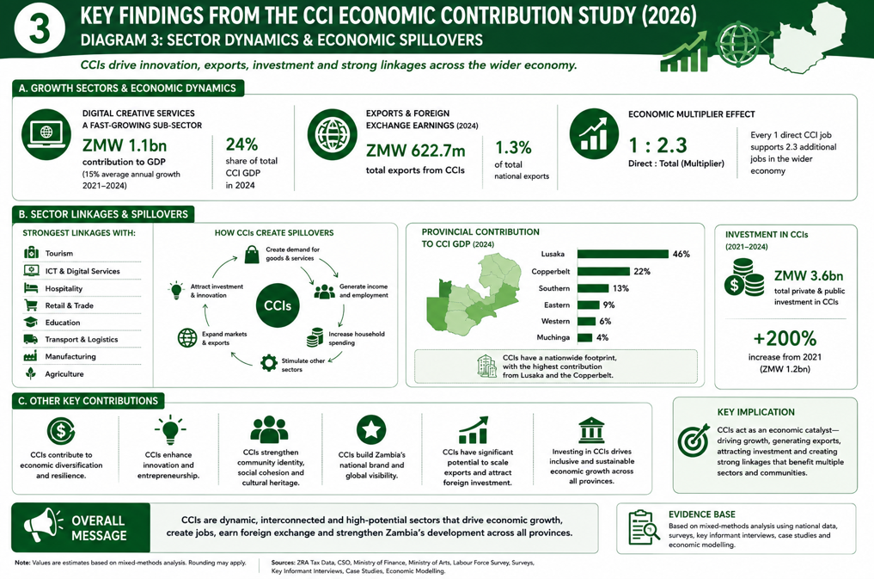

In synthesis, evidence from FGDs and KIIs confirms that Zambia’s CCIs are financially productive industries in formation rather than peripheral cultural activities. They generate substantial revenues, support widespread employment, stimulate multiple linked sectors, and contribute meaningfully to domestic revenue mobilisation though invisibly so and lacking proper systemic support mechanisms. The qualitative evidence does not merely illustrate social or cultural value; it substantiates a clear economic case for recognizing CCIs as strategic components of Zambia’s growth and diversification agenda.

chapter 9.0 Modelling Results and Analytical Interpretation

This section presents findings from the econometric and scenario-based analysis examining the relationship between public budget allocations to the arts sector and key economic outcomes, including sectoral output, employment, and fiscal performance over the period 2016–2025. The analysis combines trend analysis, regression-based elasticity estimates, and indicative multiplier assumptions derived from the emerging Social Accounting Matrix (SAM) framework described in Chapter 3.

The results should be interpreted as provisional and conservative. Given the high levels of informality, fragmented value chains, and partial coverage of creative activity in official statistics, the estimated relationships are likely to understate the full economic effects of the sector. Nevertheless, the direction, magnitude, and internal consistency of the results provide a robust basis for policy interpretation and strategic budgeting.

9.1 Public Investment and Sectoral Output Dynamics
The first set of results examines how changes in government budget allocations to the arts sector transmit into sectoral value added, measured as Arts GDP. The analysis reveals a clear and economically meaningful relationship between public investment and creative sector output.

For every one percent increase in the arts budget allocation, Arts GDP increases by approximately 0.15 to 0.25 percent, with a time lag of one to two fiscal years- see annex 1. This lag reflects the structural characteristics of creative production systems, where investment effects materialise gradually through enterprise formation, skills accumulation, project pipelines, and market development. Conversely, reductions in funding transmit much more rapidly. A ten percent cut in arts budgets is associated with a six to eight percent decline in Arts GDP within the same fiscal year, indicating a high degree of output sensitivity to fiscal contraction - (See annex 1 and 2)

- This asymmetric response is analytically significant. It suggests that creative industries are structurally vulnerable to negative fiscal shocks but capable of generating sustained output growth when investment is predictable and sustained. Unlike capital-intensive sectors, CCIs rely heavily on human capital, networks, and project continuity. When funding is withdrawn, production systems contract quickly through cancelled projects, employment losses, and firm exit. When funding increases, however, rebuilding productive capacity takes time, explaining the observed lag.

- Within the SAM framework, this pattern reflects the high labour intensity and service-sector embedding of CCIs. Public expenditure acts not merely as direct demand, but as a catalytic input that stabilises production, crowds in private investment, and enables market formation. The results therefore confirm that arts budgets influence not only cultural activity but the productive structure of the sector itself.

9.2 Multiplier Effects and Economy-Wide Spillovers

The multiplier effects indicate that each Kwacha allocated to the arts sector generates between K2.3 and K3.1 in total economic activity. This range is consistent with multipliers observed in service-intensive, labour-absorbing sectors with strong backward and forward linkages.
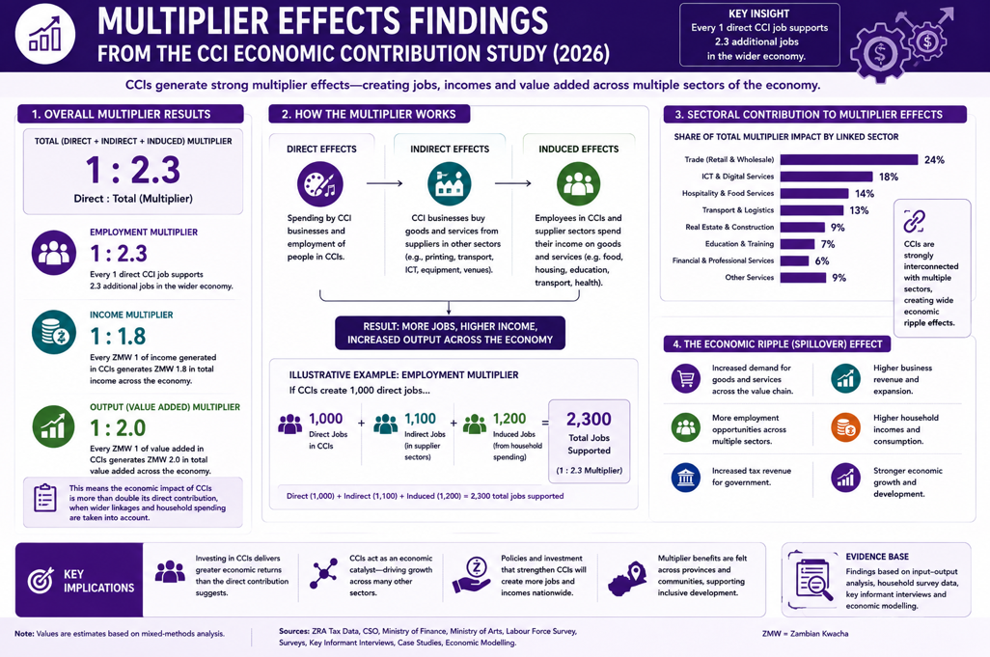

These economy-wide effects arise through three principal transmission channels. First, direct effects occur through increased production, employment, and incomes within creative enterprises. Second, indirect effects operate through supplier networks, including transport, ICT services, printing, equipment rental, hospitality, and logistics. Third, induced effects arise when creative workers spend their incomes on food, housing, transport, and retail, stimulating additional rounds of economic activity.

The magnitude of the estimated multiplier reflects the structural properties of CCIs. The sector combines low capital requirements with high employment intensity and dense service linkages, generating strong spillovers per unit of expenditure. Within the emerging SAM, CCIs rank among the most fiscally efficient employment-generating sectors, comparable to tourism and selected urban services.

From a public finance perspective, this confirms that arts spending should be treated as productive investment rather than discretionary consumption. Each unit of budgetary allocation generates multiple rounds of output, income, and employment across the economy, reinforcing the case for including CCIs within diversification and growth strategies- (See annex 1 and 2)

9.3 Fiscal Returns and Tax Revenue Elasticity
The second set of results examines the responsiveness of arts-related tax revenues to changes in public funding. The analysis reveals a strong and increasing elasticity of fiscal returns with respect to arts investment.
The research noted that there is a strong elasticity in the long term in terms of the allocation in relation to the contribution.
Short-term (1 year): 10% budget increase → 3-4% increase in arts-related tax contributions
Long-term (3 years): 10% budget increase → 7-9% increase in tax contributions

In the short term, a ten percent increase in the arts budget is associated with a three to four percent increase in arts-related tax contributions within one year. Over the medium term, the same increase yields a seven to nine percent rise in tax revenues after three years. This lagged response reflects the gradual process through which creative activity translates into formal employment, enterprise registration, VAT generation, and income tax compliance.

The fiscal transmission mechanism operates through several interrelated channels. Increased funding stabilises production and expands project pipelines, which in turn raise employment and payrolls, expanding the PAYE base. As enterprises formalize and integrate into business value chains, VAT collections increase through advertising, broadcasting, design services, and events. Over time, corporate income taxes and withholding taxes rise as enterprises scale and contracts formalise.

Within the SAM framework, these fiscal effects represent only the direct revenue channel. They do not capture the additional tax flows generated through indirect and induced effects in linked sectors. When these spillovers are taken into account, the creative economy’s contribution to domestic revenue mobilization is likely to be substantially larger than administrative data alone suggests.

The results therefore confirm that arts spending generates positive long-run fiscal feedback effects. Public investment in CCIs partially finances itself over time by expanding the tax base, strengthening compliance, and formalizing economic activity. This finding aligns closely with the administrative evidence presented in Chapter 6, where creative-sector tax revenues increased more than fivefold between 2021 and 2024.

9.4 Employment Effects and Youth Labour Market Outcomes
The employment channel emerges as one of the most policy-relevant findings of the analysis. The results indicate that increases in arts budget allocations are associated with a reduction of approximately 0.3 to 0.5 percentage points in youth unemployment.
Youth Unemployment Sensitivity:
Direct Correlation: increase in arts budget allocation correlates with 0.3-0.5 percentage point reduction in youth unemployment

This effect is large by labour-market standards and reflects the distinctive employment structure of CCIs. Creative industries exhibit low barriers to entry, high absorption capacity for semi-skilled and skilled youth, and a predominance of project-based work that generates rapid job creation. The sector also provides important pathways from informality to formalization, particularly in broadcasting, design, events management, and heritage-linked activities.

Within the SAM framework, CCIs generate among the highest employment multipliers per unit of expenditure. Because labour costs constitute a large share of total production, increases in output translate quickly into job creation. Moreover, the induced consumption effects of creative incomes further stimulate employment in retail, transport, food services, and accommodation.

From a macro-labour perspective, these results position arts spending as an effective and targeted youth employment intervention. Unlike capital-intensive sectors, which generate limited jobs per unit of investment, CCIs combine productivity gains with broad-based labour absorption, making them particularly suited to addressing urban youth unemployment and informal sector underemployment.

9.5 Optimal Allocation Ranges and Investment Efficiency
The scenario analysis reveals a non-linear relationship between arts budget allocations and economic returns, with clear thresholds for minimum viability, optimal investment, and diminishing returns.

At very low levels of funding, below approximately 0.2 percent of the national budget, allocations are insufficient to sustain institutional capacity, stabilise production systems, or prevent structural contraction. At these levels, the sector remains trapped in informality, low productivity, and fragile enterprise structures.
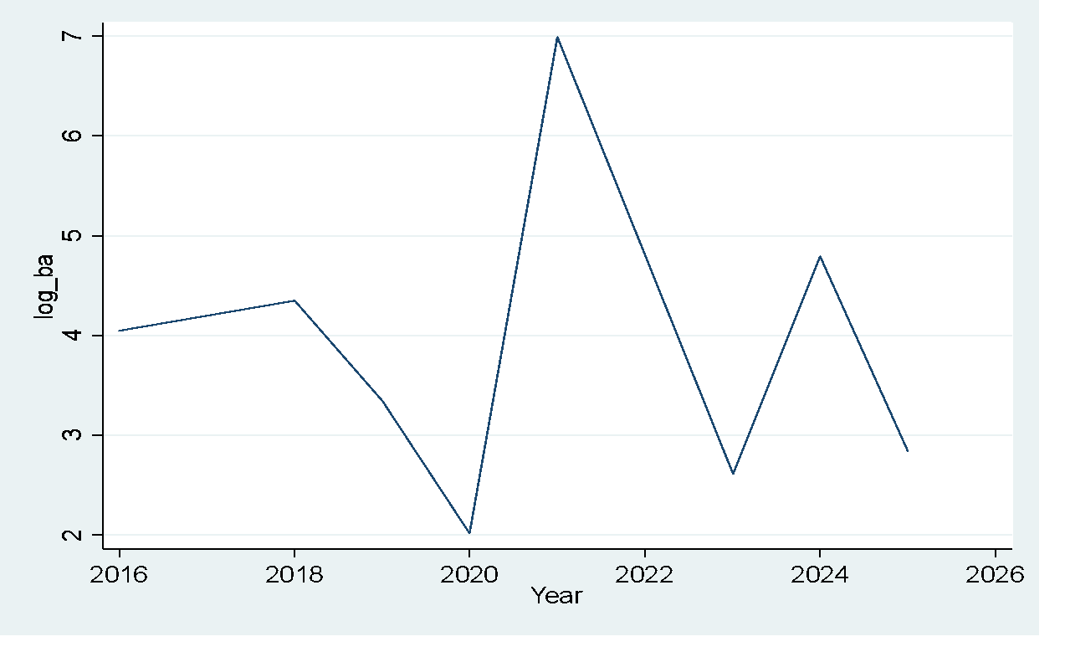
As allocations rise into the range of 0.25 to 0.35 percent of the national budget, economic returns increase sharply. Within this interval, the sector exhibits maximum output growth, employment creation, and fiscal returns. Investment in this range supports enterprise upgrading, market development, skills formation, and formalisation, unlocking the full multiplier and spillover effects identified in the SAM.
Beyond approximately 0.45 percent of the national budget, marginal returns begin to decline. At this point, absorptive capacity constraints emerge, and alternative sectors may generate higher incremental gains. This inverted-U response is fully consistent with endogenous growth and public investment theory, where both under-investment and over-concentration reduce allocative efficiency.
For Zambia, where current allocations remain below 0.1 percent of the national budget, the implication is unambiguous. The country is operating far below the efficient investment frontier of the creative economy. Moderate and strategic increases in funding would generate disproportionately high economic, employment, and fiscal returns.
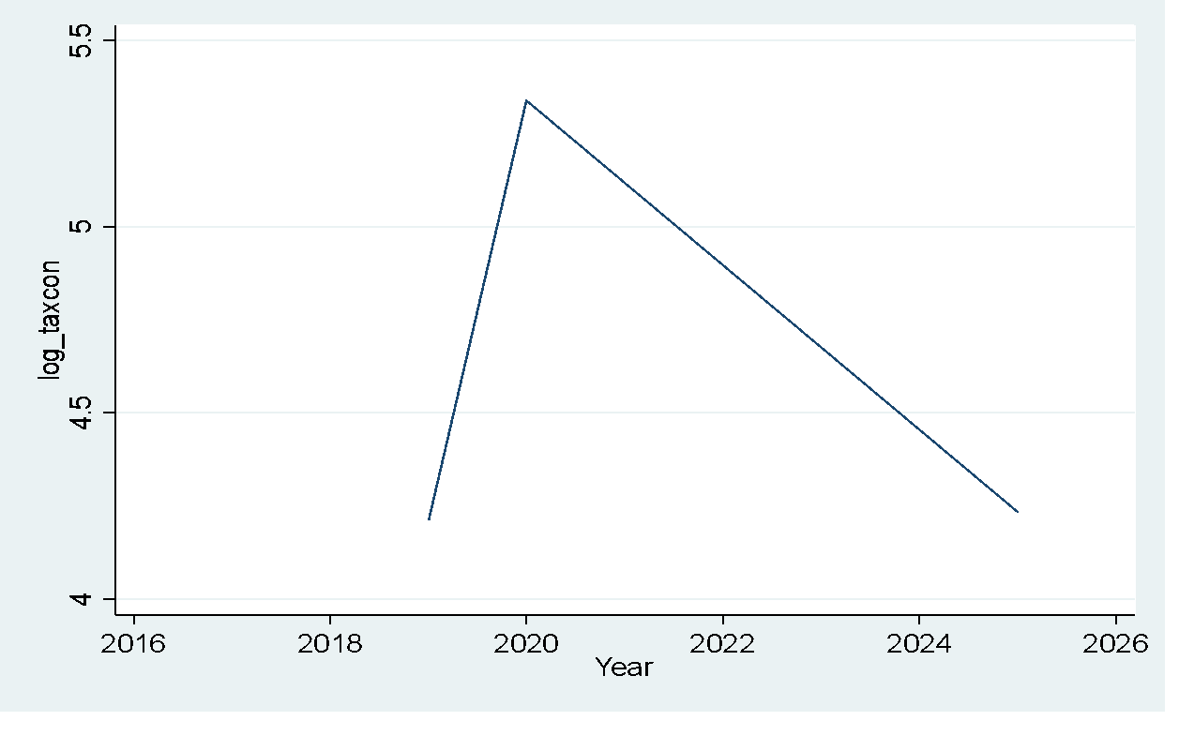
Integrated Interpretation
Taken together, the modelling results demonstrate that Zambia’s Cultural and Creative Industries function simultaneously as a growth engine, an employment generator, and a fiscal stabilizer (See annex 1 and 2)

Public investment in CCIs expands sectoral output through catalytic production effects, generates strong economy-wide spillovers through dense service linkages, creates employment at scale through labor-intensive production systems, and strengthens domestic revenue mobilisation through gradual formalisation and tax base expansion. The lag structure observed across output, employment, and fiscal channels confirms that consistency and predictability of funding are as important as funding levels themselves.

Short-term volatility produces lasting structural damage by disrupting production systems and eroding human capital. Sustained investment, by contrast, generates cumulative gains through enterprise formation, skills accumulation, market integration, and fiscal deepening.

In macroeconomic terms, CCIs combine high output multipliers, high employment multipliers, positive long-run fiscal feedback, and low capital requirements. This rare combination positions the creative economy as a strategic anchor for diversification, youth employment, and fiscal consolidation within Zambia’s medium-term development strategy.

9.6 Key Findings and Discussion

This chapter synthesises the evidence generated through administrative data analysis, primary consultations, and modelling-in-progress to present a consolidated interpretation of the current state and emerging dynamics of Zambia’s Cultural and Creative Industries (CCIs). The discussion highlights how CCIs contribute to the economy, the challenges that constrain their potential, and the structural and institutional conditions that shape opportunities for sectoral development. The formative findings already show that CCIs are economically relevant, socially significant, and fiscally visible, yet structurally under-recognised within national development planning.

- Fiscal Visibility: CCIs as an Emerging Contributor to Domestic Revenue- One of the most significant contributions of this study is its demonstration that CCIs are already fiscally relevant. Administrative tax data from the Zambia Revenue Authority shows that creative-sector tax revenues increased from K160.9 million in 2021 to K833.6 million in 2024, accounting for approximately 0.5 percent of total domestic revenue by 2025. This growth is analytically important for three reasons:
- First, it confirms that CCIs are not merely expenditure recipients but contributors to fiscal sustainability.
- Second, the increase in both revenue and registered taxpayers indicates structural expansion and gradual formalisation, rather than isolated enforcement effects.
- Third, the composition of taxes—dominated by VAT, PAYE, and Withholding Tax—demonstrates that CCIs are increasingly embedded in formal value chains and labour markets.
However, fiscal visibility is highly concentrated. Gaming, betting, and broadcasting dominate collections, masking the under-performance of other creative subsectors. Fast-growing areas such as design services, heritage, and film reveal substantial untapped revenue potential, while music remains fiscally invisible despite its cultural prominence.
Fiscal evidence confirms that CCIs are already part of Zambia’s domestic resource mobilisation architecture, but in an uneven and structurally fragile manner. Without diversification and alignment of tax instruments to creative business models, this fiscal contribution risks remaining narrow, volatile, and misrepresentative of sectoral potential.

- CCIs as a Major Source of Livelihoods and Economic Participation – Across all data
sources—Focus Group Discussions, Key Informant Interviews, enterprise surveys, and administrative records—CCIs consistently emerged as a major source of livelihoods, particularly for youth and women. This finding is reinforced by qualitative evidence showing that creative activities such as music, graphic design, event support, fashion, crafts, and digital content creation are often the first point of entry into economic participation for young people excluded from formal labour markets. In a context of high youth unemployment and constrained wage-sector absorption, CCIs act as a labour market buffer, absorbing economic shocks and offering flexible income opportunities.

The sector’s gender profile further strengthens its social relevance. Women are particularly active in fashion, crafts, food vending linked to cultural events, and heritage-based enterprises—subsectors that combine low capital barriers with community-based value chains. This positions CCIs not only as economic actors but also as instruments of inclusive growth and household resilience.

These patterns confirm that CCIs in Zambia function as livelihood systems rather than niche cultural spaces. As such, investment in CCIs should be understood as both an economic diversification strategy and a social protection intervention embedded within productive activity. The central implication is that CCIs are not simply “talent pathways” but livelihood systems, and therefore growth in CCIs contributes not only to economic diversification but also to household resilience and youth economic inclusion.

- Differential Value Capture Across Sub-Sectors- The CCIs are not economically
homogeneous. The study confirms a clear differentiation in value capture across subsectors, with broadcasting and gaming currently dominating fiscal visibility, while heritage and design services demonstrate high growth potential, and music and film remain under-capitalised and under-counted.

Broadcasting continues to anchor the sector’s formal economy due to established corporate structures, advertising-based revenue, and compliance mechanisms. Meanwhile, heritage-related enterprises — cultural centres, event-driven tourism, curated experiences — are generating expanding but uneven value, with potential strongly tied to geographical assets and visitor flows.

Design services, particularly digital graphic design, branding, and content creation, are experiencing notable growth, attributed to low entry barriers, digital interoperability, and strong links to wider business services. Stakeholders in Lusaka and Copperbelt stressed that design is increasingly becoming the “backbone of modern entrepreneurship,” as every new business requires branding and content production.

Music and film, although culturally visible, illustrate a disconnect between high creative output and low economic capture. Revenues leak at multiple value chain points — through informal performance fees, unregulated promoters, limited monetisation of digital streams, and challenges with rights management. The absence of structured financing, contract enforcement, and digital distribution channels prevents artists from scaling beyond basic survival. These variations show that growth potential is sector-specific, and a uniform policy approach risks reinforcing inequities rather than addressing structural drivers.

- Policy and Institutional Mismatch- The study found that Zambia’s policy environment for CCIs is comparatively advanced, yet weakly translated into economic outcomes. Recent reforms, including the National Arts Policy and National Film Policy, signal formal recognition of CCIs as economic sectors. However, financing remains persistently below 0.1 percent of the national budget, far below the African Union’s 1 percent benchmark. Institutional fragmentation, weak inter-ministerial coordination, and the absence of a coherent financing mechanism continue to undermine implementation. In practice, CCIs remain marginal within national development planning and borrowing frameworks despite their demonstrated alignment with diversification, youth employment, and decentralisation priorities. Zambia’s core challenge is no longer policy absence, but execution failure driven by financing misalignment, weak coordination, and limited economic integration of cultural governance.

- Fragmented Governance and Insufficient Public Investment- Institutionally, the CCIs continue to experience fragmented governance, with mandates distributed across multiple ministries and agencies. While recent policy instruments — including the National Arts Policy — signal political recognition, stakeholders repeatedly reported a disconnect between policy statements and financing allocations.

The limited share of the national budget allocated to arts and culture, despite rising evidence of economic relevance, weakens institutional capacity for sector development and reinforces a perception that CCIs are secondary to “hard” economic sectors. Cuts to local authority cultural grants in 2025 further underline the fragility of gains made under decentralisation, where provincial officers report growing expectations without matching budgets.

The outcome of this mismatch is that CCIs are expected to deliver economic, social, and cultural outcomes, yet are not resourced proportionately to generate the structural transformation required to scale the sector.

- Structural Undercounting and Economic Undervaluation of CCIs- Despite their vibrancy and livelihood importance, CCIs remain structurally undercounted within Zambia’s national accounts. Official GDP estimates of approximately 0.3 percent do not capture the scale of informal, digital, and community-based creative activity.

The dominance of informality, freelancing, and platform-based production means that a substantial share of creative value is invisible to conventional statistical and fiscal systems. Evidence from tax data and enterprise surveys suggests that the recorded economic footprint of CCIs represents only a lower bound estimate of their true contribution. Early modelling outputs and comparative evidence indicate that CCIs exhibit high output and employment multipliers, combined with low capital requirements and positive long-term fiscal feedback. This places CCIs among the rare sectors capable of delivering simultaneously on employment creation, fiscal deepening, and diversification, particularly under Zambia’s constrained fiscal conditions.

The undervaluation of CCIs is not due to economic insignificance but rather to misalignment between creative production systems and national accounting frameworks. Without corrective measurement instruments, policy decisions will continue to under-invest in one of the economy’s most accessible growth levers.

- A Transition from Informality to Emerging Formalisation- One of the most consistent patterns across the data is the slow but measurable movement from informality toward formal participation. Increased taxpayer registration, licensing, and enterprise formalisation have been observed in segments such as graphic design, events management, broadcasting-related services, and heritage-linked activities.

For example, entities providing sound, lighting, venue management, and digital services now frequently operate under registered business names and service contracts. These steps toward formalisation are associated with improved market access, higher-value contracts, and opportunities to supply institutional clients, including NGOs and private companies.

However, these gains coexist with persistent informality, especially in music, film, crafts, and live performance where irregular project cycles, limited bargaining power, and non-standard work arrangements remain dominant. The broader insight is that formalisation follows opportunity: where creative goods and services intersect with predictable markets, contractual arrangements, and institutional demand, formality becomes rational and beneficial for enterprises. Thus, policy interventions that link creatives to markets and contracting pipelines (rather than imposing compliance alone) are likely to accelerate the formalisation trajectory.

- Financing as a Systemic Constraint Limiting Scale and Innovation- Across provinces, access to finance emerged as the most persistent structural barrier, affecting both start-up and scaling trajectories. Traditional financing instruments remain misaligned with creative business models, particularly given the absence of physical collateral, unpredictable income flows, and weak record-keeping. As a result, most creative enterprises rely on personal savings, informal loans, or income reinvestment, limiting the ability to scale, automate, or reach export markets.

Despite this, where financing has been accessible — such as small equipment loans or grant-funded digital tools — enterprises have demonstrated rapid capacity gains, improved product quality, and increased earning potential. Interviews indicated that financing paired with mentorship and formalisation support yields the strongest results, suggesting that the challenge is not merely capital scarcity, but investability and risk perception.

The finding implies that strategic financing should not only provide capital, but also derisk the sector, strengthen business development services, and incentivise formal record-keeping — interventions that would simultaneously support modelling, taxation, and enterprise upgrading.

- CCIs Are Economically Active but Statistically Under-Represented- Across all dimensions, a consistent conclusion emerges: the creative economy is larger than the evidence currently shows. The gap between lived activity and recorded value is produced by informality, inconsistent data systems, and the legacy view of CCIs as culture rather than industry. This under-representation affects resource allocation and policy prioritisation, even as creative activity anchors livelihoods, youth social mobility, and local economies.

Emerging Direction: From Survival Work to Structured Economic Sector- The sector’s evolution reflects a gradual transition from survival-driven informality toward a structural economic system. The direction of movement — through growing market integration, partial formalisation, and initial revenue visibility — suggests that CCIs are not potential industries; they are industries in formation, constrained by investment choices rather than talent or demand.

- Absence of a Standardised National Definition as a Structural Constraint- A significant structural constraint identified by this study is the absence of a clear and standardised national definition of the Cultural and Creative Industries in Zambia. Across policy documents, administrative systems, and institutional practices, CCIs are inconsistently delineated, with varying interpretations of which art forms, creative practices, and value-chain activities constitute the sector. This definitional ambiguity has had concrete economic consequences: it has limited the systematic capture of creative enterprises within national accounts, business registration systems, and tax administration frameworks, thereby contributing to the persistent undercounting and undervaluation of the sector.

The lack of a unified classification has also weakened institutional coordination, as different ministries and agencies apply divergent sectoral boundaries when designing policies, allocating resources, and reporting performance. As a result, creative activities that are economically significant—particularly in digital content creation, design services, heritage-based enterprises, and informal creative production—remain partially invisible within formal economic systems despite their growing contribution to livelihoods and domestic revenue mobilisation.

This finding underscores that the challenge facing Zambia’s creative economy is not merely one of scale or informality, but of structural recognition. Without a nationally anchored definition aligned to business registration, taxation, and statistical systems, creative enterprises continue to operate in a grey zone between cultural expression and economic activity, limiting their access to finance, public support, and formal market opportunities. Addressing this definitional gap is therefore not a semantic exercise, but a foundational requirement for integrating CCIs into Zambia’s economic governance and development planning frameworks.

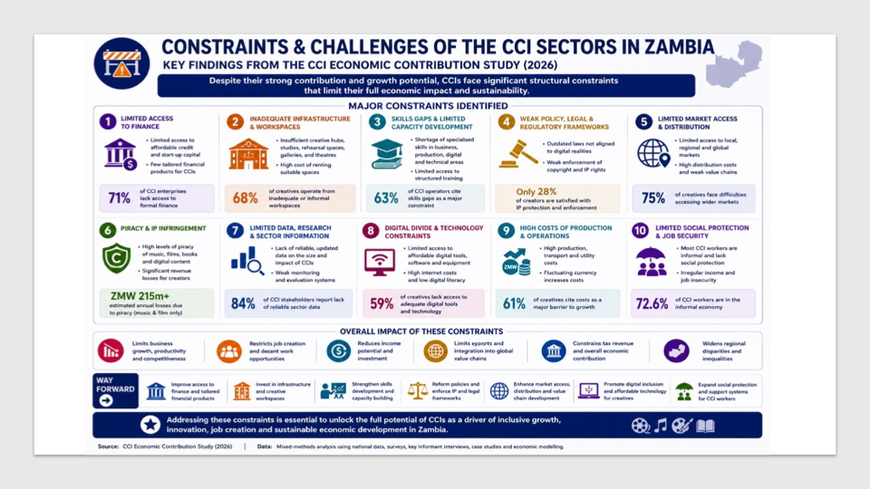

Chapter 10 The CREATE Framework for Zambia’s Creative Economy Transformation

To translate the study’s findings into a coherent and actionable reform agenda, this report proposes the CREATE Framework—an integrated policy and strategic model designed to reposition Zambia’s Cultural and Creative Industries (CCIs) as a core pillar of economic diversification, employment creation, and domestic resource mobilisation.

The CREATE Framework recognises that the primary constraint facing Zambia’s creative economy is not lack of talent or demand, but structural misalignment between creative production systems and economic policy frameworks. It therefore combines interventions across policy recognition, financing, governance, market development, and data systems to unlock the sector’s full economic potential.

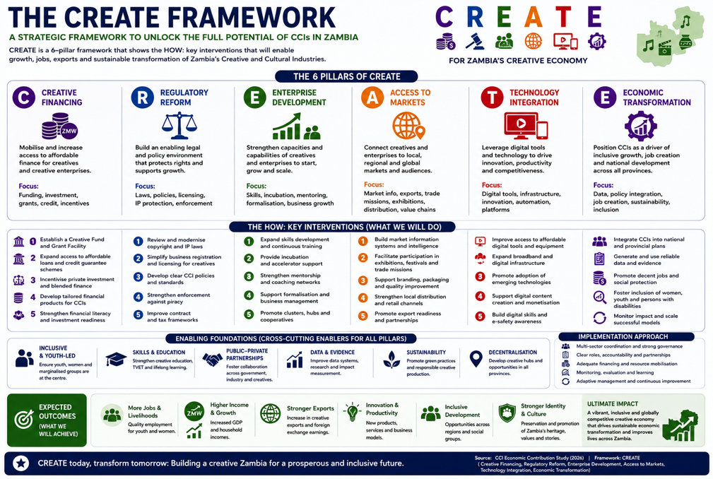

10.1 C – Classify and Recognise CCIs as an Economic Sector
A foundational step in transforming the creative economy is the formal recognition and classification of CCIs within Zambia’s economic architecture. The absence of a standardised national definition and classification framework has contributed to the systematic undercounting and undervaluation of the sector.
This pillar calls for:
- Establishing a clear, standardised national definition of CCIs aligned with business registration, taxation, and statistical systems
- Integrating CCIs into national development plans, industrial policy, and Medium-Term Expenditure Frameworks (MTEF)
- Embedding CCIs within national accounts and statistical classifications
Recognition is not merely symbolic—it is structural. It determines whether CCIs are treated as discretionary cultural activities or as productive sectors eligible for investment, financing, and policy prioritisation.

10.2 R – Resource and Finance the Creative Economy
Financing remains the most binding constraint on the growth and scalability of CCIs. Despite increasing evidence of economic contribution, public investment remains below 0.1% of the national budget, and private financing is limited due to perceived risk and weak sector data.
This pillar focuses on establishing a sustainable creative financing architecture, including:
- Creation of a Creative Economy Financing Mechanism (blended finance: public, private, donor)
- Introduction of grants, soft loans, and guarantee instruments tailored to creative enterprises
- Development of risk-sharing mechanisms to crowd in private sector investment
- Targeted financing windows for youth- and women-led enterprises

Strategic financing should not only provide capital but also de-risk the sector, support enterprise growth, and unlock its fiscal and employment potential.

10.3 E – Enable Institutions and Coordination
Zambia’s CCI ecosystem is characterised by fragmented institutional mandates and weak coordination across ministries and agencies. While policy frameworks have improved, implementation remains constrained by siloed governance structures.
This pillar proposes:
- Establishment of a Creative Economy Coordination Mechanism (e.g., inter-ministerial unit or task force)
- Strengthening the role of the National Arts Council (NAC) as a developmental and financing institution
- Enhancing coordination between MYSA, Ministry of Finance, Tourism, ICT, Trade, and Local Government
- Institutionalising civil society and private sector participation in governance structures
Effective coordination is essential to move from policy ambition to coherent, system-wide execution.

10.4 A – Activate Markets and Formalisation
The study finds that formalisation follows opportunity, not enforcement. Creative enterprises are more likely to formalise when they are linked to predictable markets, structured demand, and institutional value chains.
This pillar focuses on market activation as a pathway to formalisation, through:
- Leveraging public procurement to create demand for local creative services
- Supporting creative clusters, festivals, and cultural markets
- Strengthening linkages with tourism, ICT, advertising, and education sectors
- Promoting export development and regional market integration (AfCFTA)
By expanding market access and revenue opportunities, this approach enables creative enterprises to transition from informal survival activities to sustainable businesses.

10.5 T – Track Data and Evidence Systems
A central finding of this study is that CCIs are economically larger than current statistics suggest, but remain underrepresented due to weak data systems and measurement frameworks.
This pillar emphasises the need to build a credible and continuous evidence base, including:
- Establishment of a Creative Economy Statistical Framework
- Integration of CCIs into labour force surveys, tax data systems, and business registries
- Development of a Cultural Satellite Account (or adapted model)
- Annual publication of a Creative Economy Statistical Bulletin
Improved data systems will enhance:
- Policy credibility
- Investment decisions
- Budget justification
- Engagement with development partners
In effect, what gets measured gets funded.

10.6 E – Empower Skills and Enterprises
Sustainable growth of CCIs requires moving beyond raw talent to professionalisation, enterprise development, and skills upgrading.
This pillar focuses on strengthening both creative and business capabilities, including:
- Integration of creative and technical skills into TVET and higher education systems
- Support for creative hubs, incubators, and innovation spaces
- Provision of business development services (financial literacy, contracts, marketing, IP management)
- Investment in creative infrastructure (studios, performance spaces, digital labs)
Empowering creatives as entrepreneurs and economic actors is essential for scaling the sector and increasing its contribution to GDP, employment, and revenue.

10.7 Integrated Impact of the CREATE Framework
The CREATE Framework is designed as a mutually reinforcing system, where each pillar strengthens the others:
- Classification (C) enables better data (T) and financing (R)
- Financing (R) supports enterprise growth (E) and market activation (A)
- Market activation (A) drives formalisation and tax revenue
- Institutions (E) ensure coordination and sustainability across all pillars
Together, these interventions reposition CCIs from a fragmented, under-recognised sector into a structured economic system capable of delivering:
- Inclusive employment, particularly for youth and women
- Expanded domestic revenue mobilisation
- Economic diversification beyond extractives
- Increased resilience to external shocks
The CREATE Framework provides a clear transition pathway:
From cultural recognition → to economic activation → to structural transformation
By implementing this framework, Zambia can move beyond acknowledging the importance of CCIs and instead harness them as a strategic engine of growth, inclusion, and fiscal sustainability.

chapter 11 Policy Recommendations and Strategic Options for Zambia’s Cultural and Creative Industries

The findings of this study show that Zambia’s Cultural and Creative Industries (CCIs) are already contributing to livelihoods, employment, domestic revenue, and national identity, but remain structurally constrained by underinvestment, fragmented governance, weak financing mechanisms, and limited recognition within economic planning. The recommendations below outline strategic options for repositioning CCIs as a core pillar of Zambia’s economic diversification and inclusive development agenda.

11.1 IMMEDIATE PRIORITIES
- Reframe CCIs as an Economic Sector in National Planning- A first strategic move is conceptual: CCIs must be treated not only as a cultural or social domain, but as a productive economic sector. This requires their explicit integration into national development, industrial, youth, tourism, and employment policies. At national level, this means ensuring that forthcoming National Development Plans and Medium-Term Expenditure Frameworks recognise CCIs as a distinct area of economic activity, with clear targets for employment, enterprise growth, export development, and revenue contribution. Doing so would give ministries, agencies, and local authorities a stronger mandate to allocate resources to the sector and to defend those allocations in budget processes. This reframing also implies that Ministries of Finance, Commerce, Labour, Tourism, and Technology see CCIs as part of their own portfolios, rather than leaving the sector solely in the hands of the arts and culture administration.

- Strengthening Governance and Inter-Ministerial Coordination for CCIs- The study identifies fragmented institutional arrangements and weak inter-ministerial coordination as major impediments to the effective development of CCIs. While MYSA holds the primary mandate for arts and culture, the creative economy intersects substantively with finance, trade, tourism, education, ICT, and local government functions. Without a coherent governance mechanism linking these portfolios, policy execution remains siloed and inefficient.

It is therefore recommended that Zambia establishes a Creative Economy Coordination Mechanism, either through a dedicated Creative Economy Unit within MYSA or as a joint inter-ministerial secretariat under Cabinet Office authority. This structure should be mandated to coordinate policy implementation, harmonise investment planning, align regulatory frameworks, and monitor sector-wide performance across government. Complementing this, an Inter-Ministerial Creative Economy Task Team should be institutionalised, comprising key ministries and agencies with direct relevance to CCIs. Its role would be to ensure policy coherence, resolve operational bottlenecks, and integrate CCIs into cross-sectoral initiatives such as youth employment strategies, export promotion, decentralisation, and digital transformation.

This governance reform is critical to transitioning CCIs from a fragmented policy space into a coordinated economic sector with clear leadership and accountability.

- Institutionalising Civil Society Participation - Government should formally integrate civil society organisations (CSOs), including PAAGZ, creative hubs (e.g., Modzi Arts, BongoHive), and industry associations, into the governance and implementation architecture of the Cultural and Creative Industries.

While CSOs are already playing a critical role in training, advocacy, research, and grassroots mobilisation, their engagement remains largely informal and project-based. This limits policy coherence, weakens accountability, and results in missed opportunities for leveraging existing capacities within the sector.

In the immediate term, CSOs should be formally represented within:
- the proposed Creative Economy Coordination Mechanism,
- inter-ministerial task teams, and
- policy consultation and review processes.
Their roles should be clearly defined to include:
- policy advocacy and accountability, particularly in tracking budget allocations and implementation of national policies;
- capacity building and enterprise development, especially for informal and youth-led creatives;
- data generation and evidence building, particularly in areas where official statistics are weak (informal and digital sectors); and
- community-level mobilisation, linking grassroots creatives to national programmes and opportunities.
Institutionalising CSO participation will strengthen co-governance, enhance policy responsiveness, and improve the inclusiveness and legitimacy of sector reforms.

- Pilot Creative Enterprise Support - In the short term, Government should introduce targeted pilot interventions to support creative enterprises, particularly at the micro and small enterprise level where the majority of creative activity occurs. These pilots should include:
- Small grants for early-stage enterprises,
- equipment financing (e.g., for studios, design tools, production equipment), and
- incubation and mentorship programmes delivered through existing creative hubs and institutions.

The rationale for piloting rather than immediately scaling large financing programmes is twofold.
- First, it allows Government to test different financing models and identify what works within Zambia’s specific creative ecosystem.
- Second, it generates empirical evidence on enterprise performance, returns on investment, and employment outcomes—addressing a key evidence gap identified in this study.
Importantly, these pilots should not operate as standalone funding schemes. They should be integrated with:
- Business development services, including financial literacy, contract management, and marketing;
- Formalisation support, such as business registration and tax onboarding; and
- monitoring and evaluation systems, to track outcomes and inform scale-up.

Targeting youth and women-led enterprises will maximise the social and economic impact, given their strong representation within the sector.

- Develop Subsector-Specific Strategies, Not One-Size-Fits-All Measures- The study confirms that subsectors differ significantly in their structures, markets, and constraints. A key recommendation is to adopt subsector strategies, rather than generic interventions. For instance, music requires interventions around performance infrastructure, live event regulation, rights management, and digital monetisation, while film needs production incentives, co-production agreements, and distribution platforms. Heritage demands site investment, community benefit-sharing mechanisms, and integration with tourism circuits. Design and digital services benefit most from connectivity, skills development, and export promotion.

A practical way forward is to identify a small number of priority subsectors (for example: music, film, heritage/tourism, and design/digital services) and develop targeted roadmaps for each, with clear actions, responsible institutions, and investment requirements. These roadmaps should be short, implementable, and linked to existing policies and funding windows.

- Strengthening Intellectual Property and Monetization Systems- The underperformance of subsectors such as music and film is partly attributable to weak intellectual property enforcement, limited royalty collection, and pervasive value leakage. Strengthening IP systems is therefore central to improving income capture and fiscal visibility within CCIs.

It is recommended that PACRA, in collaboration with MYSA and rights management organizations, institutionalizes regular IP registration drives and legal clinics across provinces, targeting creatives and creative enterprises. Standardized contract templates for performances, recordings, licensing, and brand endorsements should be developed and disseminated to reduce exploitative arrangements and enhance legal certainty.

Royalty collection systems should be modernized through digital reporting, broadcaster compliance protocols, and transparent distribution mechanisms. Anti-piracy efforts should shift from blanket enforcement to intelligence-led targeting of major infringers and distributors. Improving IP governance will directly enhance enterprise revenues, export potential, and tax compliance across the sector.

- Invest in Skills, Enterprise Development, and Professionalisation- Skills and enterprise capabilities are critical for moving CCIs from survival to scale. Policy should therefore promote structured talent development and business skills, not only artistic training.
Strategic options include:
- Integrating CCI-related skills into TVET and higher education curricula (e.g. sound engineering, animation, fashion technology, arts management, cultural tourism).
- Supporting creative hubs, incubators, and innovation spaces that provide shared infrastructure, mentorship, and training in business planning, contract negotiation, financial management, and intellectual property.
- Encouraging partnerships between creative training institutions and the private sector, so that curricula reflect real market needs and learners gain practical experience.

By combining artistic talent with entrepreneurial skills, Zambia can nurture a generation of creative professionals capable of building sustainable businesses, employing others, and participating in regional and global value chains.

- Strengthen Data, Measurement, and Evidence Systems- A recurrent theme in this study is that CCIs are economically larger than the statistics suggest. To correct this, investment in data and measurement systems is essential.

In the short term, this means continuing to refine the CCI economic model and Z-SAM work, improving assumptions, expanding subsector disaggregation, and integrating new data as it becomes available. It also means building a simple, regularised process for capturing administrative data (registrations, tax, grants, local revenues) across institutions.

In the medium term, Zambia can explore steps toward a Cultural and Creative Industries Satellite Account or similar mechanism adapted to local realities. This would create a more systematic way of tracking the sector’s contribution to GDP, employment, and trade. Strengthening data will not only support evidence-based policy; it will also give cultural actors a stronger platform to engage with economic decision-makers.

- Leverage Decentralisation and Provincial Development- CCIs are inherently place-based: they are rooted in local languages, histories, and practices. Decentralisation offers a unique opportunity to align cultural development with territorial economic strategies.

Local authorities can be encouraged and supported to integrate CCIs into local economic development plans, tourism strategies, and youth employment initiatives. This may include support for festivals and cultural events, creative markets, heritage route development, and local creative clusters around music, crafts, or digital content. To make decentralisation meaningful, local authorities require predictable and earmarked resources for culture and CCIs, as well as technical support and simple planning tools. National policy can reinforce this by linking certain grants or programmes to performance-based criteria, such as the number of cultural initiatives supported, local revenue generated, or partnerships established.

- Establish a Clear and Standardized National Definition of the Cultural and Creative Industries- It is recommended that Zambia establishes a clear, standardised, and nationally recognised definition of the Cultural and Creative Industries (CCIs) that explicitly articulates which art forms, creative practices, and value-chain activities constitute the sector. A coherent national classification framework is essential for strengthening policy coherence, enhancing institutional coordination, and ensuring consistent recognition of the sector’s economic and social contributions across government and development partners.

Such a definition would play a critical role in improving the measurement and quantification of the sector’s contribution to GDP, employment, and domestic revenue by enabling creative enterprises and activities to be systematically captured within formal economic and statistical systems. In particular, aligning the national CCI definition with existing formalisation mechanisms—such as business registration through PACRA, tax compliance frameworks administered by ZRA, and sector-specific regulatory and revenue systems—would facilitate the transition of creative enterprises from informality to formality.

Beyond improving data quality, a standardized definition would strengthen the evidence base for public investment, private-sector participation, and targeted financing instruments, thereby supporting more strategic and sustainable growth of Zambia’s creative economy. In this regard, the national definition of CCIs should be embedded within Zambia’s industrial classification systems, national accounts, and development planning frameworks to ensure its operational relevance and durability.

It is therefore recommended that ZamStats, in collaboration with ZRA, PACRA, MYSA, and NAC, establishes a Creative Economy Statistical Framework to systematically capture data on creative employment, enterprise performance, fiscal contribution, and trade. This should begin with improved administrative data integration and labour force survey modules and progressively evolve toward the development of a Cultural Satellite Account adapted to Zambia’s context. Annual publication of a Creative Economy Statistical Bulletin would significantly strengthen transparency, inform MTEF processes, and enhance Zambia’s capacity to mobilise domestic and external financing for CCIs.

11.2 Medium-Term Priorities (2–5 Years)

- Modernising Statutory Institutions for Development-Oriented CCIs- While Zambia possesses statutory bodies responsible for arts and heritage governance, notably the National Arts Council (NAC) and the National Heritage Conservation Commission (NHCC), their mandates and operational frameworks remain largely regulatory and custodial rather than developmental. This limits their capacity to drive enterprise growth, mobilise financing, and facilitate investment within CCIs.

It is therefore recommended that the ongoing review of the National Arts Council Act be used as a strategic opportunity to reposition NAC as a developmental institution with explicit responsibilities for creative enterprise support, financing administration, infrastructure development, and provincial cluster coordination. This would enable NAC to move beyond grant disbursement and regulation toward playing a catalytic role in the creative economy.

Similarly, the NHCC Act should be modernised to strengthen the economic integration of heritage into tourism, local economic development, and community-based enterprise models. Legal provisions should enable benefit-sharing mechanisms, heritage concessions, and partnerships with local authorities and private investors.

Modernising these statutory bodies will enhance institutional effectiveness and anchor CCIs within Zambia’s broader economic governance framework.

- Move from Ad Hoc Grants to a Structured Creative Financing Architecture - One of the most binding constraints identified is access to finance. To address this, Zambia can move from fragmented, project-based grants to a structured creative finance ecosystem. A viable strategy is the establishment of a Creative Economy Fund or Facility, anchored in public resources but designed to crowd in private and donor co-financing. Such a facility could offer a mix of small grants, soft loans, and guarantee instruments targeting different parts of the value chain: start-up seed for youth enterprises; equipment financing for production and design houses; and scale-up capital for export-ready firms.

To avoid repeating past weaknesses, this mechanism should be implemented with professional financial management, clear eligibility criteria, transparent selection, and strong technical assistance and business development support for beneficiaries. A portion of the fund could specifically target women- and youth-led creative enterprises, in line with Zambia’s broader equity and inclusion objectives. At the same time, public financial institutions and commercial banks should be encouraged to develop tailored lending products for creative businesses, supported by training on how to assess creative business models and revenue streams. Blending instruments, where donors share risk with local banks, can help change perceptions of CCIs from “too risky” to “investable with support”.

- Align Tax Policy with Sector Growth and Formalisation- The tax analysis shows that CCIs already contribute substantially to domestic revenue, particularly through broadcasting, gaming, VAT, and PAYE. Yet many subsectors remain under-captured, not because they lack activity, but because their business models do not fit neatly into existing tax instruments. The strategic option is not to increase the tax burden on creatives, but to align tax policy with sector growth and formalisation. This could include the development of:
- Simplified tax regimes for micro and small creative enterprises, with lower compliance costs and clear guidance on how to register, declare income, and benefit from being in the system.
- Event-based compliance models for live performances and festivals, where organisers and venues carry primary responsibility for withholding and remitting taxes, rather than placing the burden on individual artists.
- Clearer classification and guidance for digital earnings, to ensure that platform-based income can be disclosed in a straightforward way, without triggering disproportionate penalties or administrative complexity.
These measures would support formalisation, improve revenue mobilisation over time, and build trust between CCIs and revenue authorities.

- Public Procurement for Creative Services - Government should introduce policies that prioritise the procurement of creative goods and services from local creative enterprises as part of its broader public expenditure framework. Currently, a significant proportion of government demand for services such as branding, media production, advertising, digital content, event management, and design is either outsourced informally or captured by non-local providers. This represents a missed opportunity to stimulate domestic creative industries.

A structured public procurement approach would:
- create predictable and stable demand for creative services;
- support the formalisation of creative enterprises, as participation in procurement requires compliance with registration and tax systems; and
- enhance quality standards and professionalism within the sector.

To operationalise this, Government can:
- introduce procurement guidelines or quotas for sourcing creative services locally;
- develop framework contracts for creative service providers; and
- build capacity within creative enterprises to meet procurement requirements (e.g., bidding processes, compliance standards).
Over time, public procurement can act as a catalytic market, enabling creative enterprises to scale, build portfolios, and transition into private and export markets.

- Creative Infrastructure Development - Investment in creative infrastructure is essential for unlocking productivity, improving quality, and enabling market access across the Cultural and Creative Industries. At present, the sector is constrained by limited access to:
- professional recording studios,
- performance venues and theatres,
- exhibition and gallery spaces, and
- digital production facilities.
This lack of infrastructure not only limits production capacity but also contributes to informality, reduces income potential, and constrains the development of competitive creative enterprises.
A strategic approach to infrastructure development should include:
- public investment in shared creative spaces, such as cultural centres, studios, and performance venues;
- public-private partnerships (PPPs) to develop and manage creative infrastructure; and
- integration of creative infrastructure into urban and regional planning frameworks, particularly within decentralised local development strategies.

Importantly, infrastructure investments should be aligned with subsector needs—for example:
- performance venues for music and theatre,
- production facilities for film and audiovisual industries, and
- digital labs for design and content creation.
Well-designed infrastructure not only supports production but also generates employment, stimulates tourism, and creates hubs of economic activity.

11.3 Long-Term / Structural Priorities (5–10 Years)

- Position CCIs within Regional and Continental Opportunities- Zambia’s CCIs should be linked more intentionally to regional and continental creative markets. The African Continental Free Trade Area (AfCFTA), regional streaming platforms, festival circuits, and creative market platforms offer opportunities for Zambian creatives to reach wider audiences and export services. Policy can support this by:
- Facilitating participation in regional festivals, markets, and trade fairs,
- Promoting regional co-productions and collaborations, especially in film and music,
- Aligning national regulations with regional protocols on intellectual property and digital trade.
By positioning Zambian CCIs within the wider African creative economy, the country can leverage its cultural assets not only for domestic development but also for regional influence and foreign exchange generation.

- Institutionalising Creative Economy Data and Measurement Systems- Finally, the long-term sustainability of CCIs as an economic sector depends critically on the quality of data and evidence available to policymakers, investors, and development partners. The persistent under-measurement of CCIs continues to undermine their policy prioritisation and investment appeal.

- Digital Monetisation and Platform Development – In the long term, Zambia should develop a comprehensive strategy to strengthen digital monetisation and improve value capture from creative content distributed through digital platforms. While digital technologies have expanded access to markets, a significant share of value generated by Zambian creatives is captured by global platforms, resulting in substantial revenue leakage. This is particularly evident in music, film, and digital content creation.

A strategic response should include:
- support for the development of local and regional digital platforms, particularly in streaming, distribution, and content aggregation;
- capacity building for creatives on digital monetisation strategies, including content optimisation, licensing, and audience engagement; and
- regulatory and policy frameworks that improve transparency and fairness in digital revenue-sharing arrangements. In addition, the government should explore opportunities to:
- integrate digital creative industries into broader ICT and digital economy strategies; and
- leverage regional markets through AfCFTA to expand digital exports.

Strengthening digital monetisation is critical for ensuring that creative production translates into sustainable incomes and contributes meaningfully to domestic revenue mobilisation.

- Institutionalise Annual Creative Economy Reporting - To sustain policy relevance and support evidence-based decision-making, Zambia should institutionalise the annual publication of a Creative Economy Statistical Bulletin. This publication, led by ZamStats in collaboration with MYSA and other relevant institutions, would:
- provide regular updates on the sector’s contribution to GDP, employment, and revenue;
- track trends across subsectors; and
- assess the impact of policy and investment interventions.
The absence of consistent and reliable data has been identified as a major constraint in the sector, contributing to underinvestment and weak policy prioritisation. An annual reporting mechanism would address this gap by improving transparency, strengthening accountability, and providing a credible evidence base for:
- budget allocations,
- investment decisions, and
- engagement with development partners.

Over time, this reporting system should evolve into a more comprehensive measurement framework, including the development of a Cultural Satellite Account, ensuring that CCIs are fully integrated into Zambia’s national economic statistics.

12.Conclusion
This study set out to reposition Zambia’s Cultural and Creative Industries (CCIs) from the margins of cultural discourse to the centre of economic development planning. The evidence presented throughout this report confirms a fundamental shift in understanding: CCIs are not peripheral or symbolic sectors, but functioning economic systems embedded within labour markets, fiscal structures, and interconnected service value chains.
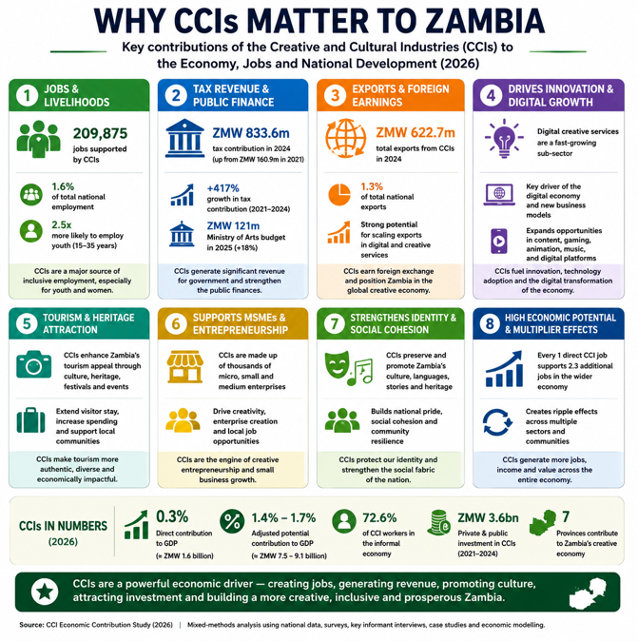
Across all dimensions of analysis, the findings demonstrate that CCIs are already contributing meaningfully to Zambia’s economy. They serve as a critical source of livelihoods—particularly for youth and women—while simultaneously emerging as contributors to domestic revenue mobilisation through expanding tax participation and gradual formalisation. In this regard, the creative economy must no longer be viewed solely as a recipient of public expenditure, but as a productive and revenue-generating component of the national economy.
Yet, despite this demonstrated relevance, the sector remains structurally undervalued and undercounted. The persistence of informality, the rise of digital production, and weak integration into national statistical systems continue to obscure the true scale of creative economic activity. This invisibility has had tangible consequences: it has limited policy prioritisation, constrained public investment, and weakened the case for sustained financing, even as the sector aligns closely with Zambia’s strategic objectives of economic diversification, employment creation, and fiscal resilience.
The analysis further reveals that CCIs are not a uniform sector, but a diverse and evolving ecosystem. While broadcasting and gaming currently anchor fiscal visibility, subsectors such as design, heritage, and digital services exhibit strong growth trajectories. Conversely, music and film—despite their cultural prominence—remain constrained by weak monetisation systems, fragmented value chains, and limited access to finance. These dynamics underscore a central policy insight: unlocking the full potential of CCIs requires differentiated, targeted interventions rather than one-size-fits-all approaches.
Taken together, the findings point to a clear strategic conclusion. Zambia’s creative economy is not a future opportunity waiting to be developed—it is an existing economic system that is already active, but constrained. Its growth is limited not by a lack of talent or demand, but by gaps in recognition, financing, coordination, and measurement. Addressing these constraints offers a high-impact pathway for advancing inclusive growth, strengthening domestic revenue mobilisation, and reducing dependence on traditional sectors.
The pathway forward is therefore not conceptual, but practical. With deliberate reforms—anchored in coherent policy frameworks, sustained financing, institutional coordination, market development, and robust data systems—CCIs can transition from fragmented creative activity into a structured and scalable economic sector. In doing so, they can support dignified livelihoods, expand the national tax base, reinforce Zambia’s cultural identity, and contribute meaningfully to long-term economic transformation.
Ultimately, this report affirms that creativity is not merely an expression of culture—it is a strategic economic asset. The choice ahead is whether Zambia continues to under-recognise and underinvest in this asset, or whether it deliberately activates it as a driver of inclusive, resilient, and diversified growth.

References
- African Union. (2015). Agenda 2063: The Africa we want. African Union Commission.
- Bank of Zambia. (2022, 2023, 2025). Annual reports and export statistics.
- Gilmore, A. (2014). Raising our quality of life: The importance of investment in arts and culture. Centre for Labour and Social Studies.
- Government of the Republic of Zambia. (2003). National culture policy.
- International Labour Organization (ILO) & African Union. (Various years). Reports on digital economy an
- Ministry of Youth, Sport and Arts. (2023). National arts policy. Government of the Republic of Zambia.
- Organisation for Economic Co-operation and Development (OECD). (2021). Economic and social impact of cultural and creative sectors: Note for Italy G20 Presidency Culture Working Group. OECD.
- Organisation for Economic Co-operation and Development (OECD). (2018). Financing and investment frameworks for cultural and creative sectors: Innovation in public investment for arts and culture (Discussion Note, C1). OECD.
- Organisation for Economic Co-operation and Development (OECD). (2018). Culture and local development: Background document. OECD.
- Selam. (2024). A baseline study on assessing public investment in the arts and culture sector: Zambia. Selam.
- United Nations Conference on Trade and Development (UNCTAD). (2010). Creative economy report. United Nations.
- United Nations Conference on Trade and Development (UNCTAD). (2022). Creative economy outlook. United Nations.
- United Nations Educational, Scientific and Cultural Organization (UNESCO). (2005). Convention on the protection and promotion of the diversity of cultural expressions.
- United Nations Educational, Scientific and Cultural Organization (UNESCO). (Various years). Cultural satellite accounts framework.
- World Intellectual Property Organization (WIPO). (2015). Guide on surveying the economic contribution of the copyright industries.
- Zambia Revenue Authority (ZRA). (2021–2025). Administrative tax data on cultural and creative industries.
- Zambia Statistics Agency (ZamStats). (Various years). National accounts and labour force survey reports.

ANNEX: Scenario 1 - Budget Allocation to Arts regression

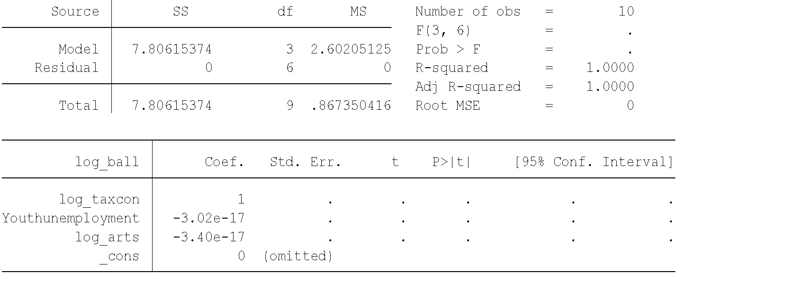
ANNEX 2: Budget Allocation to Arts
